

The Thirsty Cloud
  - Meeting the water needs of Singapore's data-centre growth
DSS5202 Sustainable Systems Analysis | Term Paper | Group 29
Aditya Vijindra Pandhari | A0328872R
Apurwa Kumari | A0333260R
Vanshika Dhamija | A0333989H
November 2026
ABSTRACT
Singapore plans to add data-centre capacity, and these sites need cooling water. We compare four ways to supply and use that water for 200 MW of new IT load from 2027 to 2035: wet cooling with desalinated water (A1), wet cooling with NEWater (A2), high-concentration towers that recover their blowdown (A3), and a dry cooling loop with a small wet trim (A4). We estimate water demand, then compare the options on carbon (life cycle assessment), cost (life cycle costing) and a wider set of criteria, such as technical maturity and policy fit, using the Analytic Hierarchy Process (AHP), a method that scores the options against weighted criteria. NEWater with ordinary towers is the cheapest option for society. Recovery (A3) saves about 30% of the water and 25% of the emissions, and it saves the operator money, but it costs society slightly more. Dry cooling (A4) saves the most water but uses so much extra electricity that its emissions and cost are many times higher. We rank the options under five weightings that stand for different stakeholder priorities: a balanced view, PUB's concern for water security, the operator's concern for cost, a climate-focused view and a growth-focused view. A3 ranks first under four of the five. Dry cooling (A4) moves ahead of A3 only in the water-security view, where saving water carries more than about half of the total. The analysis gives PUB, IMDA, EDB and prospective operators a common per-MWh basis for comparing cooling-water options, and it identifies the few site measurements, chiefly the energy penalty of dry cooling, that would change the choice.

1. Introduction
Data centres reject their heat to the air, and many do it by evaporating water in cooling towers. In Singapore, where water is imported or made at a high energy cost, that water use is a policy concern. The second Data Centre Call for Application (DC-CFA2) provisionally allocated 200 MW of new IT capacity to four proposals (Economic Development Board & Infocomm Media Development Authority [EDB & IMDA], 2026). The Government has since put the country's planned maximum IT load at 1.6 GW, which includes this allocation (Ministry of Digital Development and Information [MDDI], 2026).

We ask a practical question: how can Singapore meet the cooling-water needs of new data centres at reasonable cost, with low carbon, and without straining the water system? We compare four options on a common basis of 1 MWh of IT energy, then test how far the answer depends on our assumptions.
The four options are shown in Figure 1. All four share the same liquid-cooled IT equipment. They differ only in the water source and in how heat is rejected.
Figure 1. The four options. Each row shows the water source, the heat-rejection method and the resulting water use per MWh of IT energy. In a wet cooling tower the warm water from the data centre is cooled by letting part of it evaporate into the air. The water that stays behind becomes steadily saltier, so some of it has to be drained (the blowdown), and both the evaporated and the drained water are replaced with fresh make-up water. 'Cycles of concentration' is how many times saltier the circulating water is allowed to become than the make-up water before it is drained: at 3 cycles about one-third of the make-up water leaves as blowdown, at 8 cycles about one-eighth. '70% of blowdown recovered' means that 70% of the drained water is treated on site and returned to the tower instead of being discharged. A dry loop releases heat to the air through finned coils and fans, like a car radiator, and uses water only as a 'wet trim' on the hottest hours.
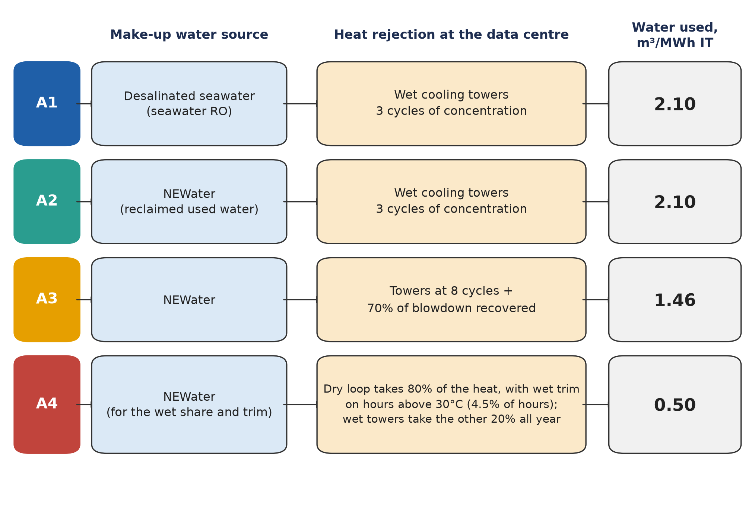
Table 1 explains the terms used in the rest of the report. Table 2 maps the five questions in our proposal to the method that answers each one.
Table 1. Terms used in this report.
Term | Meaning
IT energy | Electricity used by the computing equipment itself. Our unit of comparison is 1 MWh of it.
WUE | Water-use effectiveness: cubic metres of water used per MWh of IT energy (the same number as litres per kWh).
PUE | Power-use effectiveness: total facility energy divided by IT energy. We use the extra PUE that dry cooling adds.
NEWater | High-grade reclaimed water made from treated used water.
Cycles of concentration (CoC) | The ratio of dissolved solids in the circulating tower water to those in the make-up water. A higher number means less water is drained as blowdown.
Blowdown | The salty water drained from a cooling tower to keep it clean.
Wet trim | Water-assisted cooling used on hot hours by the dry loop in A4.
Make-up water | Fresh water added to a cooling tower to replace what evaporates and what is drained as blowdown. It is the water the data centre has to buy, and it is what WUE measures.
Evaporative (wet) cooling tower | Equipment that cools the warm water coming from the data centre by letting part of it evaporate into the air, much as sweat cools skin. Evaporation removes the heat but uses up the water.
Dry cooler (dry loop) | Equipment that releases heat to the air through finned coils and fans, like a car radiator, without evaporating water. It uses no water but needs more fan electricity, especially on hot days.
Heat rejection | The last step of cooling, in which the heat collected from the servers is released to the outside air, by a wet tower, a dry cooler or a combination of the two.
Blowdown recovery | Treating the blowdown on site, usually with membranes, so that most of it can go back into the tower instead of being discharged. Used in A3 only.
Utilisation | The average share of the installed IT capacity that is actually drawing power over a year. We assume 70%.
Commissioning ramp | The period after a data centre is built during which its load rises gradually to the mature level as customers move in. We assume 3 years.
LCA and LCC | Life cycle assessment (LCA) adds up the environmental burden, here carbon emissions, of every step from water production to heat rejection. Life cycle costing (LCC) does the same for costs, spreading equipment that is bought once over the years it is used.
AHP | Analytic Hierarchy Process: a way of ranking options against several criteria at once. Each criterion gets a weight, each option gets a score on each criterion, and the weighted scores are added up.
Sensitivity tests | Checks of how much the results move when the inputs move. A tornado analysis changes one input at a time; a Monte Carlo simulation changes all uncertain inputs at once, many times over; a break-even value is the input value at which a conclusion flips; a structural case changes how an option or the model is set up rather than a single number.

Table 2. Research questions from the proposal and the evidence used to answer them.
Question | Assessment | Reported metric
Q1 Additional water required | Capacity and utilisation model | Annual and cumulative m³
Q2 Water demand avoided | Cooling-tower water balance (evaporation, blowdown and make-up water) and the share of hot hours in the weather record | WUE and avoided m³
Q3 Cost and carbon | Life cycle costing (LCC) and a simplified life cycle assessment (LCA) of carbon | S$/MWh and kg CO₂e/MWh
Q4 Wider decision factors | AHP with stated judgments | Priorities by weighting case
Q5 Dependence on assumptions | Parameter, preference and structural tests | Intervals, rank frequencies and thresholds

Five groups have a stake in the answer. PUB manages water supply and demand and sets the efficiency benchmarks. IMDA and EDB set the conditions attached to data-centre growth. Operators pay for equipment, water and electricity and must meet reliability requirements. The Energy Market Authority (EMA) has an interest because water treatment and cooling both draw on the grid. Households and other industries share the same water system. The AHP in Section 7 represents these concerns through five illustrative weightings. It does not measure any organisation's actual preferences.
The report follows the method in Figure 2. Section 2 sets the scope and Section 3 the data. Section 4 estimates demand. Sections 5 and 6 cover carbon and cost. Section 7 ranks the options with the Analytic Hierarchy Process (AHP). Section 8 tests the results. Sections 9 to 11 draw out the findings. Detailed tables, equations and checks are in the supplementary section after the references.
Figure 2. Method overview. Demand feeds both the carbon and cost assessments. The AHP combines them with other criteria, and the sensitivity tests check the inputs and the weights. 'Tornado' means changing one input at a time between its low and high value to see which inputs move the result most. 'Monte Carlo' means varying all the uncertain inputs together, many times over. 'Break-even' is the value an input would have to reach for a conclusion to flip. 'Weight sweeps' vary how much importance each AHP criterion is given. 'Structural cases' change how an option or the model itself is set up, for example making A3 use desalinated water instead of NEWater, rather than changing a single number.
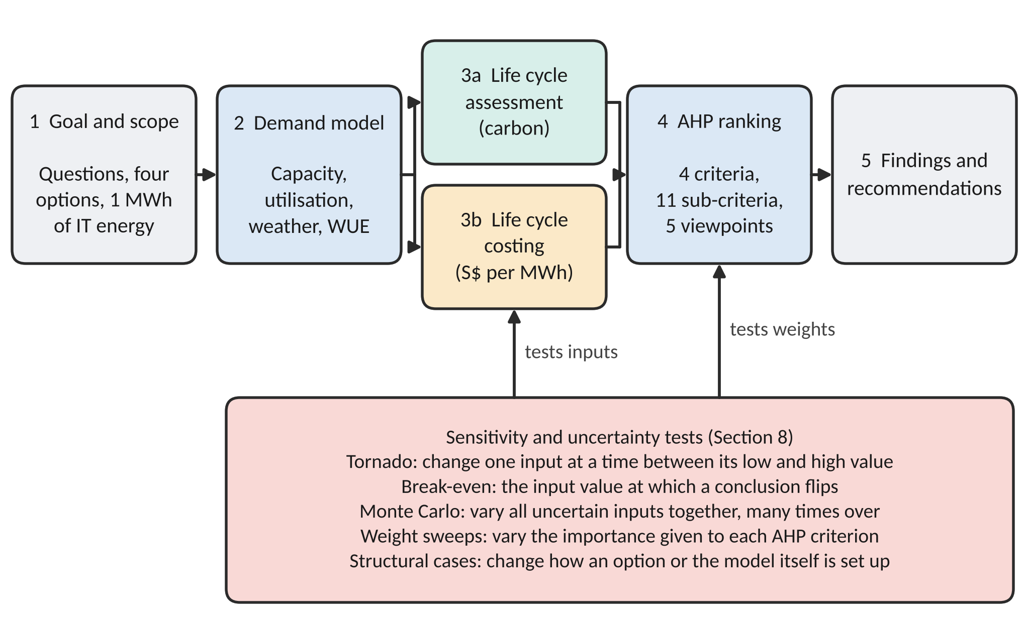

2. Scope and system boundary
What we compare. The functional unit is the heat rejection that goes with 1 MWh of IT energy, including the make-up water it needs. The study period is 2027 to 2035. The base case is the 200 MW allocation (scenario S1). Two larger cases, 500 MW (S2) and 700 MW (S3), are hypothetical growth scenarios.
What is inside the boundary. Figure 3 follows the convention of ISO 14040 (International Organization for Standardization [ISO], 2006a). Everything inside the dashed line is counted. Arrows outside the line are flows to and from the environment.
Figure 3. System boundary for 1 MWh of IT energy. Solid arrows are flows inside the system. Dashed boxes are outside it.
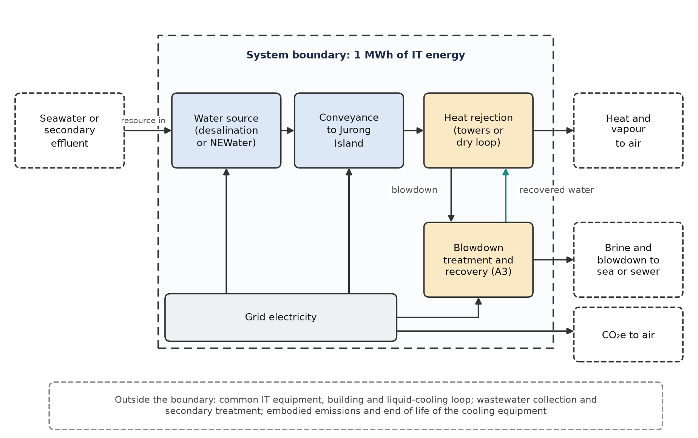
Inside the boundary are the steps that differ between the options. Water production is the making of usable water, either by desalinating seawater or by purifying treated used water into NEWater. Conveyance is pumping that water to the data-centre sites on Jurong Island. Heat rejection is the equipment that releases the servers' heat to the outside air, either cooling towers that evaporate water or dry coolers that rely on fans. Blowdown recovery (A3 only) is the on-site treatment that cleans the water drained from the towers so that it can be reused. The extra fan electricity for dry cooling (A4 only) and the electricity used by all of these steps are also counted. Outside the boundary are the IT equipment, the building and the liquid-cooling loop that carries heat away from the servers, because all four options share them and they would add the same amount to each. We also leave out two things for which we could not find reliable data on how the options differ. The first is the collection and basic treatment of used water before it reaches the NEWater plant; we count the NEWater process from the point where that treated effluent enters it. The second is the embodied emissions of the cooling equipment, meaning the emissions from manufacturing and installing it. This second omission matters most for A3 and A4, which need extra equipment, and we have not quantified how much it could shift their ranking.
Our carbon figures are therefore a screening estimate of the components listed. Brine and blowdown are reported as volumes. A litre of brine from desalination and a litre of tower blowdown do not have the same ecological effect, and the AHP treats the volume only as a proxy.

3. Data and assumptions
Our main sources are the Public Utilities Board (PUB) for water benchmarks, tariffs and energy figures (PUB, 2023a, 2023b, 2025); the Energy Market Authority for the grid emission factor (EMA, 2026); IMDA and EDB for the policy context (EDB & IMDA, 2026; IMDA, 2024); and hourly Open-Meteo weather data for Jurong Island, 2015 to 2025 (Open-Meteo, n.d.). Mytton (2021) and Shehabi et al. (2024) give background on cooling and water accounting. None of these gives measured performance for the new Singapore sites. The 200 MW allocation is treated as IT capacity, not facility power, because MDDI (2026) counts it within the 1.6 GW IT-load figure.
Table 3 lists the inputs that matter most. Each input has a base value, a range used in the sensitivity tests, and an evidence status. Verified means we found a published source for the base value. Team judgement means it is our own assumption. For desalination energy the base value is published but the range is ours.
Table 3. Key inputs. Ranges are test ranges unless the evidence column says otherwise. The full register is in Table S1.
Parameter | Base | Low–high | Evidence status
Average utilisation, fraction | 0.70 | 0.50–0.85 | to-verify
Wet-rejection WUE, m³/MWh | 2.10 | 2.00–2.20 | benchmark-derived
High cycles of concentration | 8.00 | 6.00–12.00 | to-verify
Blowdown recovery, fraction | 0.70 | 0.50–0.80 | team-judgement
Additional dry-rejection PUE | 0.05 | 0.02–0.10 | team-judgement
Share of heat to the dry loop (A4) | 0.80 | 0.70–0.90 | team-judgement
Recovery capex, S$/MW IT | 60,000.00 | 30,000.00–120,000.00 | team-judgement
Dry-rejection premium, S$/MW IT | 100,000.00 | 0.00–300,000.00 | team-judgement
Desalination energy, kWh/m³ | 3.50 | 2.00–4.00 | base verified; range assumed
NEWater energy, kWh/m³ | 0.70 | 0.60–1.00 | to-verify
Resource electricity proxy, S$/kWh | 0.20 | 0.15–0.25 | proxy
Operator electricity, S$/kWh | 0.25 | 0.20–0.30 | proxy
Social discount rate, % | 3.00 | 2.00–5.00 | team-judgement
Operator discount rate, % | 8.00 | 6.00–10.00 | team-judgement

Of the 60 entries, 8 are verified, 14 still need checking and 25 are team judgements. Of the 39 inputs that enter the model, 5 are verified. We say this early because it shapes how the results should be read. The cost and electricity penalty of dry cooling, the share of heat that dry cooling can take, the cost of recovery equipment and the non-energy emission factors are all our assumptions.
Two price points matter later. PUB's NEWater price is S$2.50/m³ before GST, and the non-domestic potable price is S$3.24/m³ (PUB, 2023b, Annexes A and B). The operator pays these. There is no separate tariff for desalinated water, so A1 uses the potable price as a proxy for the operator's bill. The resource-cost calculation does not use tariffs at all, because they include taxes and transfers.

4. Water demand
How demand is calculated. For each block of capacity, annual IT energy is the capacity multiplied by utilisation, the commissioning ramp and 8,760 hours. Water demand is that energy multiplied by WUE. We assume 70% utilisation and a 3-year ramp for each block. Utilisation is the share of the installed computing capacity that is actually drawing power, averaged over the year, so a 1 MW block at 70% utilisation uses the same energy as 0.7 MW running continuously. The ramp is the period after a block is built during which it fills up with customers and its load rises to that mature level. The 2035 figures therefore describe every block at its mature average load, which is below its maximum.
How WUE is set for each option.
- A1 and A2: a standard evaporative tower at 3 cycles of concentration, meaning the circulating water is allowed to become three times as salty as the make-up water before it is drained, so one-third of the make-up water leaves as blowdown and two-thirds evaporates. We scale a heat-balance curve (the relationship between heat removed, water evaporated and water drained) to the PUB (2025) benchmark of 2.10 m³/MWh.
- A3: the same tower run at 8 cycles, which needs better water treatment to stop the saltier water from scaling and corroding the tower but cuts the blowdown from one-third to one-eighth of the make-up water. Of the blowdown that remains, 70% is treated on site and returned to the tower instead of being discharged. WUE falls to 1.46 m³/MWh. Running at 8 cycles alone gives 1.60 m³/MWh, so about 78% of A3's saving comes from the higher cycles and the rest from recovery (Table 12).
- A4: a dry loop takes 80% of the heat. The other 20% goes through wet towers all year. The dry loop also needs wet trim when the air is hotter than 30°C, which is 4.5% of hours in our weather record. WUE falls to 0.50 m³/MWh, of which 0.42 comes from the year-round wet share and 0.08 from the hot-hour trim. The A4 water figure therefore depends mainly on the assumed 80/20 dry-wet split, which is a team judgement, and less on the weather. Section 8 shows what a warmer record does to it.
Figure 4 shows where each option sits. The curve shows how fast the tower's water use falls as cycles of concentration rise, and it flattens after about 8 cycles. That is why A3 also needs recovery, and why A4 needs a different approach altogether. The Green Data Centre Roadmap target of 2.0 m³/MWh (IMDA, 2024) is marked for comparison.
Figure 4. Water use against cycles of concentration, with the four options marked. The curve is calibrated to the PUB benchmark of 2.1 m³/MWh.
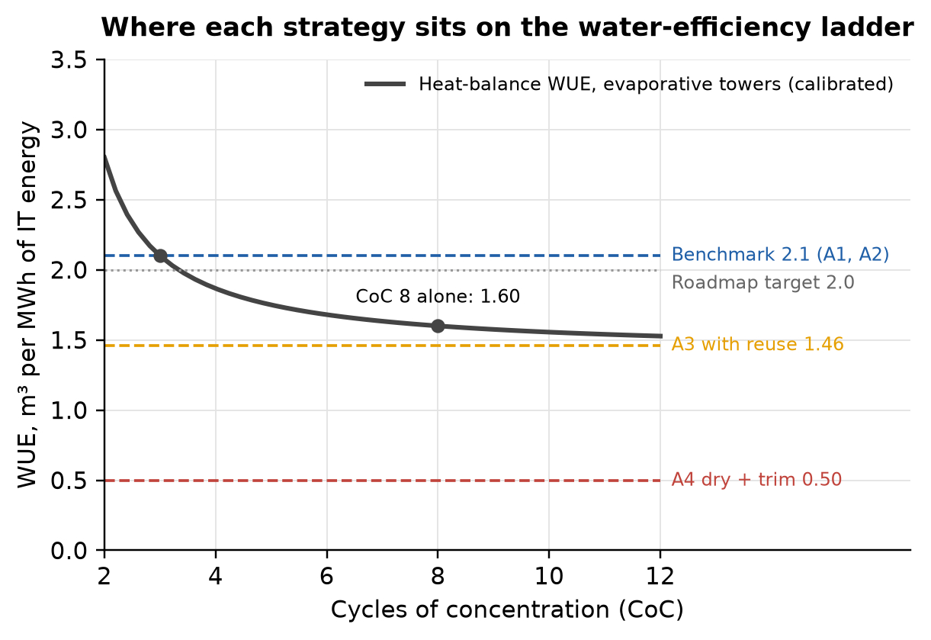
Table 4 gives the resulting annual demand in 2035. For the 200 MW case, ordinary towers use 2.58 million m³ a year. A3 uses 1.79 million m³ and A4 uses 0.61 million m³. The base case is about 0.38% of the 669 million m³ of potable water and NEWater sold in Singapore in 2025 (Department of Statistics Singapore, 2026b). That share is small. It is a scale comparison only; most of that national volume is not cooling water.
Table 4. Annual make-up water in 2035, million m³. S2 and S3 are hypothetical total-capacity cases with the same utilisation and cooling assumptions.
Scenario | Total MW IT | A1 / A2 | A3 | A4
S1 | 200 | 2.58 | 1.79 | 0.61
S2 | 500 | 6.44 | 4.48 | 1.52
S3 | 700 | 9.01 | 6.27 | 2.13

The larger scenarios only scale the totals. They do not change which option uses less water per MWh. The ranking of the options is the same in S1, S2 and S3, so we use S1 for most of the analysis.

5. Life cycle assessment: carbon
We follow the four phases of ISO 14040 (ISO, 2006a): goal and scope (Sections 2 and 3), inventory, impact assessment and interpretation.
Inventory. For each option we count the electricity used to produce water, move it to the island, treat recovered blowdown and run any extra dry-cooling fans. Production energy is the make-up water multiplied by the energy needed per cubic metre: 3.5 kWh for desalination (PUB, 2023a) and 0.7 kWh for NEWater, a team screening value inside a 0.6 to 0.8 kWh/m³ range we recorded for NEWater treatment without retaining the source document. Conveyance adds 0.3 kWh/m³ and recovery treatment 1.0 kWh per m³ recovered; both are team screening assumptions with test ranges. Table S1 states, for every input, either the verified source or that no verified source is established. Dry cooling adds 0.05 to the PUE, which is 50 kWh per MWh of IT energy. We also add a small non-energy emission term for plant construction and chemicals.
Impact assessment. We convert electricity to carbon using the grid emission factor. It starts at 0.404 kg CO₂/kWh in 2025 (EMA, 2026, Table 2.3) and falls to an assumed 0.38 in 2035; the 2027 to 2035 average of 0.3896 kg CO₂/kWh is used for the per-MWh comparison. We do not treat the 50% green-energy commitment attached to DC-CFA2 as zero emissions for half the supply, because the official pathways include biomethane, ammonia and hydrogen (Ministry of Energy, Trade and Industry [METI], 2026), and we do not treat their lifecycle emissions as zero. The factors are operational CO₂ combined with assumed CO₂-equivalent inventory terms, not a gas-by-gas characterisation.
Why climate change and water use only. ISO 14044 asks that the impact categories fit the goal of the study (ISO, 2006b). Our question is about water supply for data-centre cooling, so we quantify the two categories that separate the options: climate change (kg CO₂e per MWh) and make-up water demand (WUE, a withdrawal measure, not consumptive use). We also report electricity use and brine or blowdown volume. We looked at other midpoint categories, such as acidification, particulate matter, eutrophication and ecotoxicity, and did not model them separately. We had no Singapore-specific data to characterise them and we do not claim a ranking for them. We do not report endpoint damage to health or ecosystems, because that needs value-laden factors built for other regions. The AHP keeps carbon, water, electricity and discharge as separate criteria, so none of them is hidden in a single score.
Results. Table 5 and Figure 5 show the results per MWh of IT energy.
Table 5. Electricity and carbon per MWh of IT energy. Carbon uses the average grid factor of 0.3896 kg CO₂/kWh.
Option | Electricity for water, kWh | Extra fan electricity, kWh | CO₂e from electricity, kg | CO₂e non-energy, kg | Total CO₂e, kg
A1 Wet + desal | 7.98 | 0.0 | 3.11 | 0.32 | 3.42
A2 Wet + NEWater | 2.10 | 0.0 | 0.82 | 0.17 | 0.99
A3 Towers + reuse | 1.60 | 0.0 | 0.62 | 0.12 | 0.74
A4 Dry + wet trim | 0.50 | 50.0 | 19.67 | 0.04 | 19.71

Figure 5. Modelled carbon emissions by component. A4's extra fan electricity dominates.
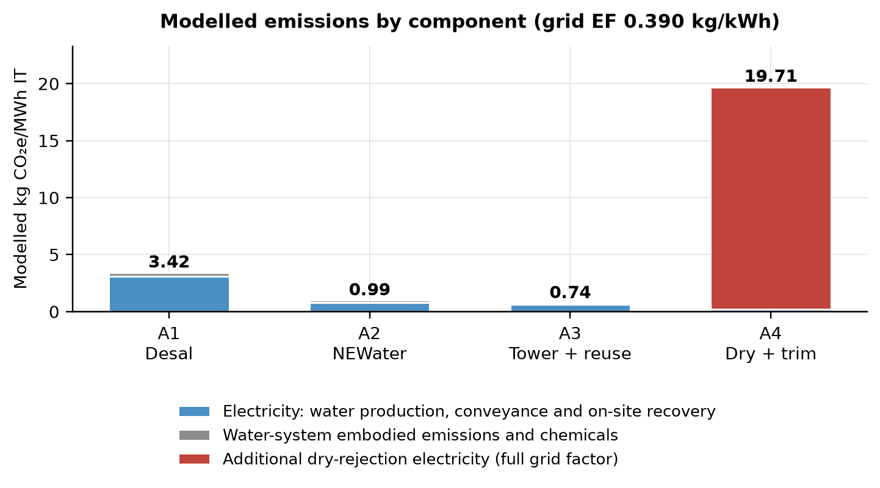
Interpretation. A3 has the lowest emissions, 0.74 kg CO₂e/MWh, about 25% below A2. It uses less water to treat and move, and recovery energy is small. A1 emits 3.42 kg because desalination needs five times the energy of NEWater. A4 emits 19.71 kg, about 20 times A2, because its 50 kWh of extra fan electricity far outweighs the water-production energy it saves. This does not mean dry cooling always emits more. Against A2, the extra dry-cooling PUE would have to be about 0.0019 or lower for the two to emit the same amount at the base grid factor. That is a very small penalty, and measurements would be needed to know whether a real system can reach it.

6. Life cycle costing
We cost each option from two points of view, because the answer differs. Figure 6 shows how the costs are built up.
Figure 6. Cost flow. The same physical quantities are priced twice: once as a resource cost to society and once as the bill the operator pays.
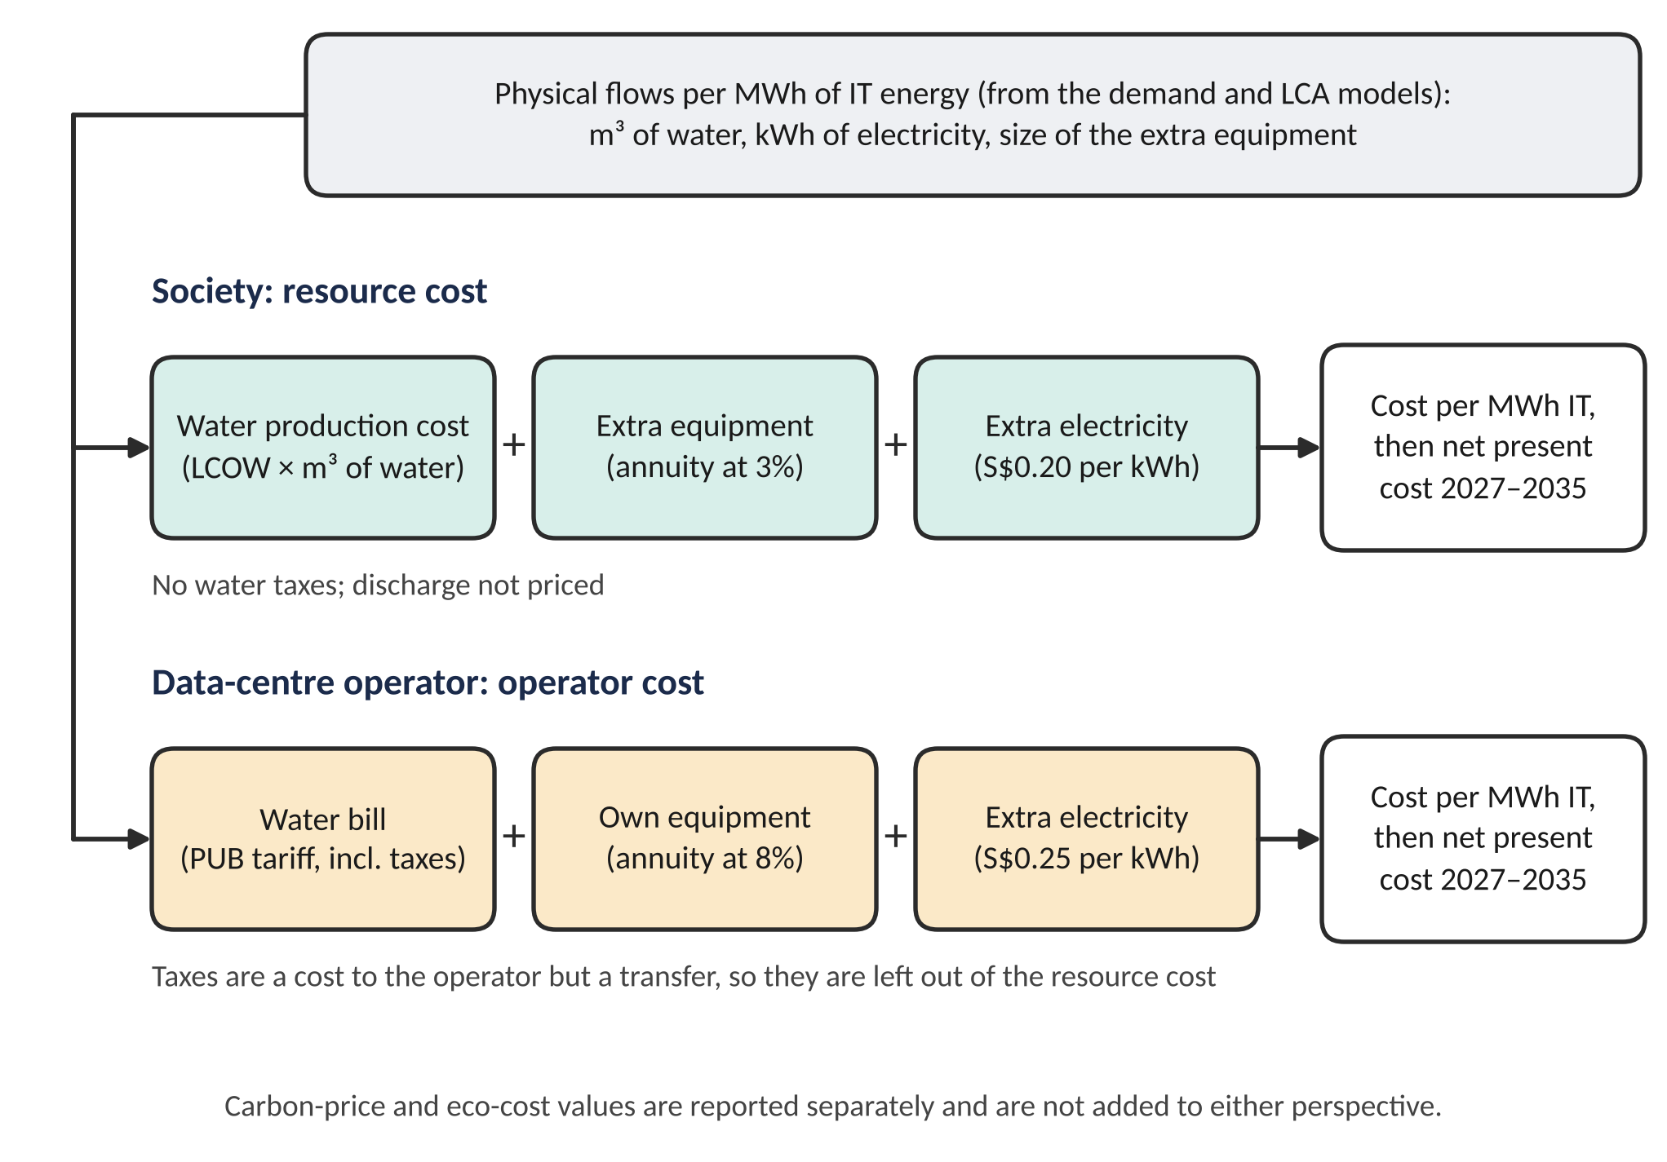
Resource cost (society's perspective). This counts what it costs to provide the water and run the equipment, using a 3% social discount rate, an electricity price of S$0.20/kWh, and no water taxes. We call it the resource cost throughout. The cost of water comes from a levelised cost of water (LCOW): the annualised plant capital, plus non-energy running costs, plus electricity, all divided by the water produced. We get S$1.18/m³ for desalination and S$0.41/m³ for NEWater. For context, the second Changi NEWater plant was awarded at S$0.276/m³ in its first year (PUB, 2014). Differences in year, financing and contract scope mean this does not validate our figure.
Operator cost. This counts what the data-centre owner pays: the PUB water tariff, equipment capital at an 8% discount rate, and electricity at S$0.25/kWh. Water taxes are part of the operator's bill, but they are a transfer, not a resource cost to society.
Equipment costs. Extra equipment is turned into an annual charge using the capital recovery factor over a 15-year life. For A3 the recovery equipment is assumed to cost S$60,000 per MW of IT load. For A4 the dry-cooling premium is S$100,000 per MW. These are our assumptions. Once a block is commissioned, its equipment incurs this fixed annual charge during the load ramp as well; only variable costs scale with output (Section S6). A worked example is in Section S2.
Carbon valuation. We also priced the emissions in two separate ways: a carbon-price equivalent using the announced S$45/t for 2026 to 2027 and S$65/t, the midpoint of the published S$50 to 80 range for 2030 (National Climate Change Secretariat [NCCS], 2026), and an eco-cost of €0.15/kg CO₂e (Sustainability Impact Metrics, 2026). With the eco-cost added, the resource costs become S$3.35, 1.21, 1.70 and 15.89/MWh for A1 to A4, and the order does not change. Neither valuation enters the main cost figures or the AHP, because electricity prices may already carry the carbon tax. The eco-cost factor is read from the emissions sheet of the published workbook, which is labelled 2025.
Results. Table 6 gives the cost per MWh at mature utilisation. Table 7 gives the net present cost over 2027 to 2035 for the 200 MW case.
Table 6. Base-case results per MWh of IT energy. Costs are before GST. Emissions cover the modelled water and heat-rejection components only.
Configuration | Water m³ | GHG kg CO₂e | Resource cost S$ | Operator cost S$
A1 Wet + desal | 2.10 | 3.42 | 2.60 | 6.80
A2 Wet + NEWater | 2.10 | 0.99 | 1.00 | 5.25
A3 Towers + reuse | 1.46 | 0.74 | 1.54 | 4.83
A4 Dry + wet trim | 0.50 | 19.71 | 11.60 | 15.64

Table 7. Discounted cost over 2027 to 2035 for the 200 MW case, S$ million. Equipment charges start when each block is commissioned.
Perspective | A1 | A2 | A3 | A4
Resource costs | 21.79 | 8.35 | 13.86 | 98.71
Operator costs | 44.59 | 34.41 | 32.91 | 104.64

Figure 7. Cost per MWh by component, for society (left) and for the operator (right). A4's cost is almost all extra fan electricity.
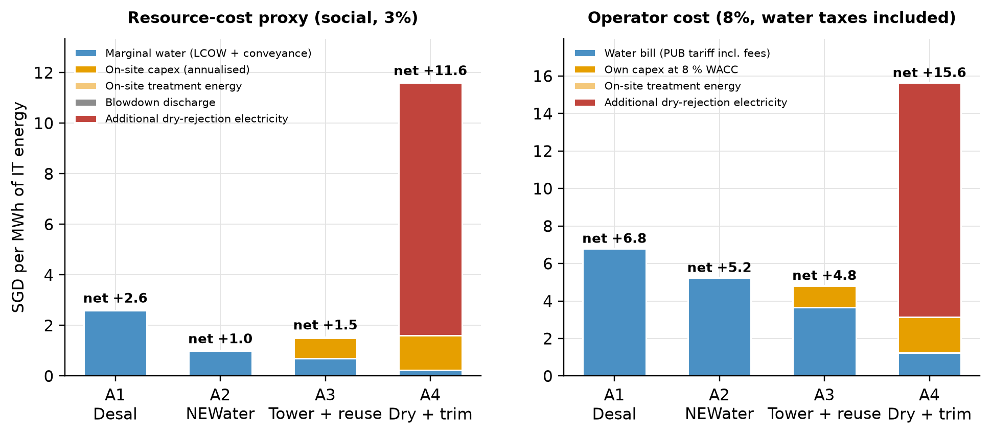
Interpretation.
- A2 is the cheapest for society, at S$1.00/MWh. Switching from desalinated water (A1, S$2.60) to NEWater cuts the resource cost by more than half.
- A3 costs society S$0.54 more than A2. The recovery equipment costs more each year than the value of the water it saves. For the operator it is the reverse: the avoided water bill is bigger, so A3 saves S$0.42/MWh. That saving excludes maintenance, chemicals and membrane replacement for the recovery unit, which we could not cost. An extra operating cost of about S$2,587 per MW of IT per year, 4.3% of the assumed equipment capital, would remove it at mature utilisation. Over the 2027 to 2035 horizon, with the commissioning ramp, the discounted operator advantage is S$1.5 million; a fixed charge of about S$1,200 per commissioned MW-year, or S$0.23/MWh if proportional to throughput, removes it.
- The break-even is a tariff of S$1.84/m³. If NEWater cost the operator less than that, A3 would not pay off. The current price is S$2.50/m³.
- A4 is far more expensive, at S$11.60/MWh for society and S$15.64 for the operator, about 12 times A2 for society. Fan electricity is almost the whole cost. Even with no electricity penalty at all, A4 would cost society S$1.60/MWh because of its capital premium, so resource-cost parity with A2 needs a lower premium or a net electricity advantage. Operator-cost parity needs an extra PUE below 0.0084 and carbon parity below 0.0019 (Table 11).

7. Multi-criteria ranking with AHP
Cost, carbon and water use pull in different directions, and some things, such as technical maturity, are not on a numerical scale. We use the Analytic Hierarchy Process (Saaty, 1980) to bring them together.
The hierarchy. Figure 8 shows the structure: four main criteria (economic, environmental, water security and implementation) and 11 sub-criteria. Six sub-criteria are calculated from the model (marked Q). Five are pairwise judgements by the team (marked P). Tables S7 and S8 explain each one.
Figure 8. The AHP hierarchy with balanced weights. Q marks scores taken from the model. P marks team judgements.
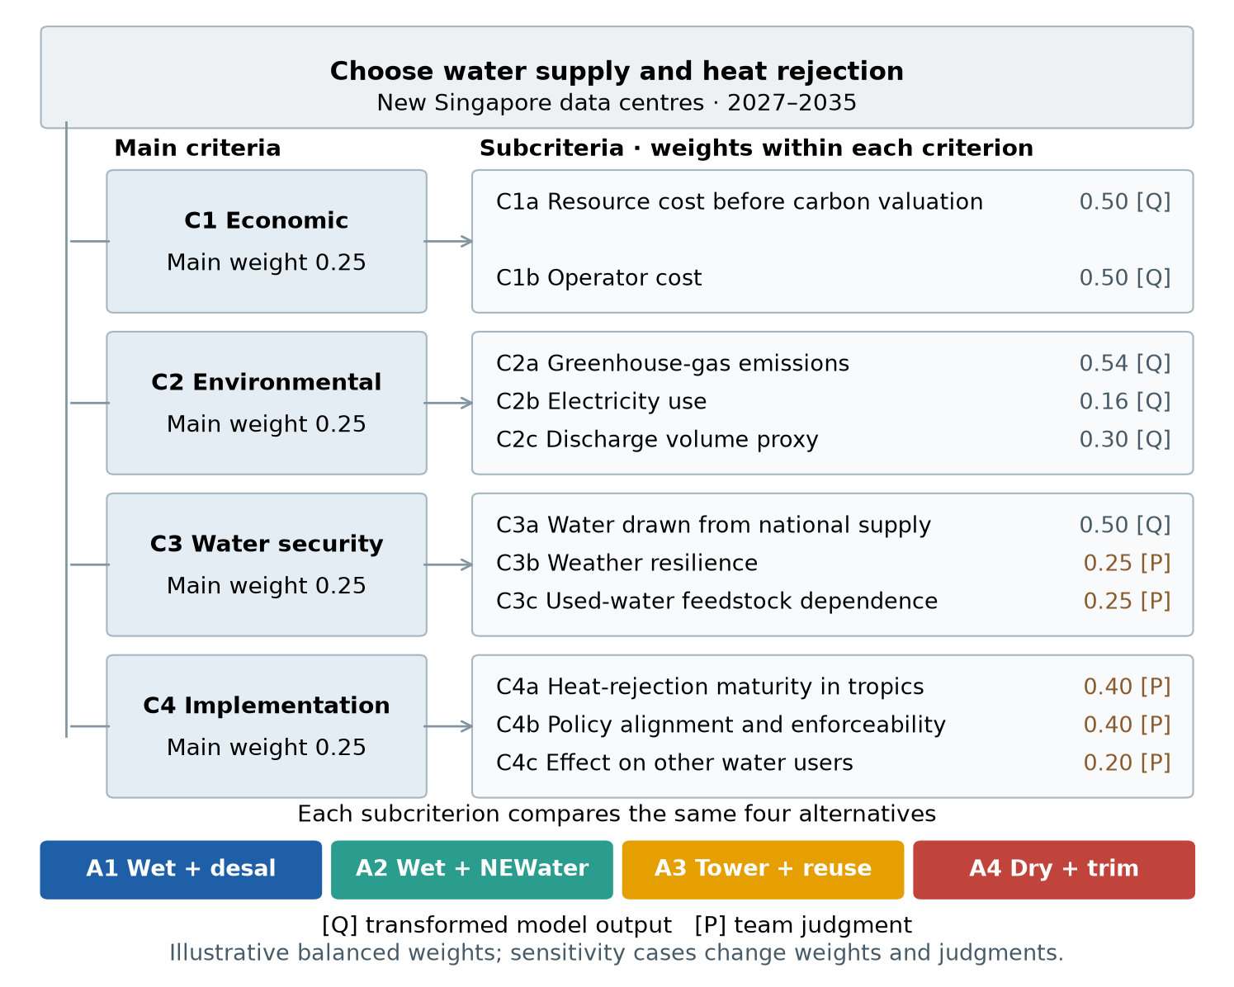
How scores work. For a Q criterion we use a linear rule: the best option gets the highest score and the worst the lowest, with a small floor so that no option scores zero. This rule is a choice, and Section 8 tests the alternative ratio rule. For a P criterion, we compare the options two at a time on Saaty's 1-to-9 scale and check the consistency ratio, which must stay at or below 0.10. Ours is at most 0.022. A low ratio shows internal agreement among the judgements, not their empirical validity. An option's final score is the sum of its criterion scores multiplied by the weights. The scoring rule and a worked sum are in Section S7.
Five viewpoints. We do not know whose preferences will decide, so we test five sets of main-criterion weights (Table 8). These are illustrations of what different groups might care about. The operator viewpoint raises the weight on the economic criterion; the two cost sub-criteria stay equal, so it is an economic-emphasis case rather than a pure operator objective. The weather-resilience sub-criterion scores all four options equally, because every option must meet the same reliability requirement; it tempers the water-security criterion rather than separating the options, and the reduced-overlap case in Section 8 drops it.
Table 8. Main-criterion weights in each viewpoint.
Viewpoint | C1 Economic | C2 Environmental | C3 Water security | C4 Implementation
W1 Balanced | 0.25 | 0.25 | 0.25 | 0.25
W2 PUB / water security | 0.12 | 0.12 | 0.54 | 0.22
W3 Operator / economic | 0.48 | 0.13 | 0.14 | 0.26
W4 Climate (EMA, NGOs) | 0.12 | 0.54 | 0.19 | 0.15
W5 Growth (IMDA, EDB) | 0.32 | 0.14 | 0.14 | 0.39

Table 9. AHP scores under the five viewpoints with the linear scoring rule. Each row adds to about 1. The highest score in each row is the first-ranked option.
Weighting | A1 | A2 | A3 | A4
W1 Balanced | 0.231 | 0.250 | 0.299 | 0.220
W2 PUB | 0.218 | 0.190 | 0.273 | 0.318
W3 Operator | 0.249 | 0.279 | 0.308 | 0.163
W4 Climate (EMA, NGOs) | 0.223 | 0.265 | 0.312 | 0.199
W5 Growth (IMDA, EDB) | 0.235 | 0.265 | 0.299 | 0.201

Figure 9. AHP scores under the five viewpoints.
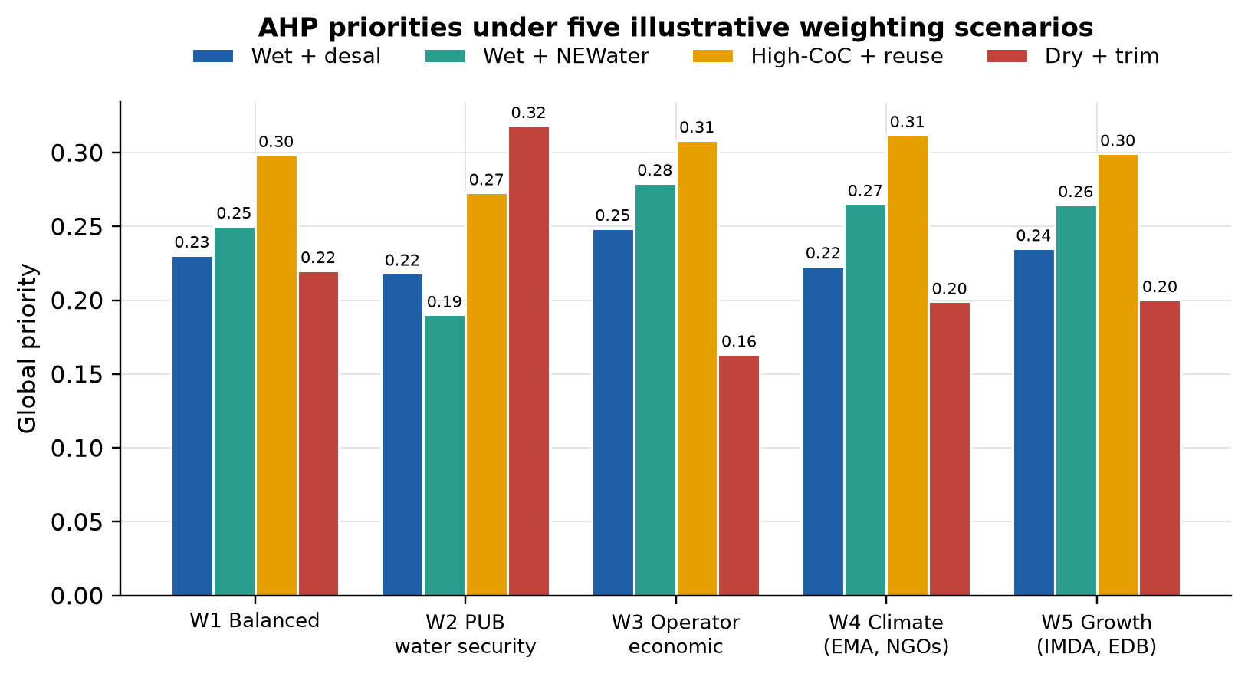
What the ranking says.
- Under balanced weights the order is A3, A2, A1, A4. A3 scores 0.299.
- A3 is first in four of the five viewpoints under the linear rule. It is a good all-rounder: lowest carbon, a reasonable cost and a real water saving. Under the ratio rule the operator viewpoint becomes a near tie, with A2 numerically first (Table 14).
- A4 is first only under the PUB water-security viewpoint, where water security carries about 54% of the weight. In the weight sweep of Figure S2, A4 overtakes A3 once that weight passes about 0.46.
- A2 never ranks first under the linear rule. It wins on resource cost, but a ranking that also values water and implementation prefers A3.
The AHP gives a ranking under stated judgements and a stated scoring rule. It should be read together with the separate cost, carbon and water results.

8. Sensitivity and uncertainty
We use a one-way (tornado) analysis, Monte Carlo simulation and rainbow plots for the AHP weights, and add break-even checks, structural cases, a scoring-rule test and a weather check to find where the conclusions can flip. Design details are in Section S9.
One input at a time (tornado). Figure 10 shows which inputs move the cost most. For A1 it is desalination energy and the plant electricity price. For A2 it is NEWater operating and capital cost. For A3 it is the recovery equipment cost. For A4 it is the extra dry-cooling PUE, which on its own moves cost from about S$6 lower to S$10 higher per MWh.
Figure 10. Five largest cost drivers for each option, changing one input at a time from its low to its high value.
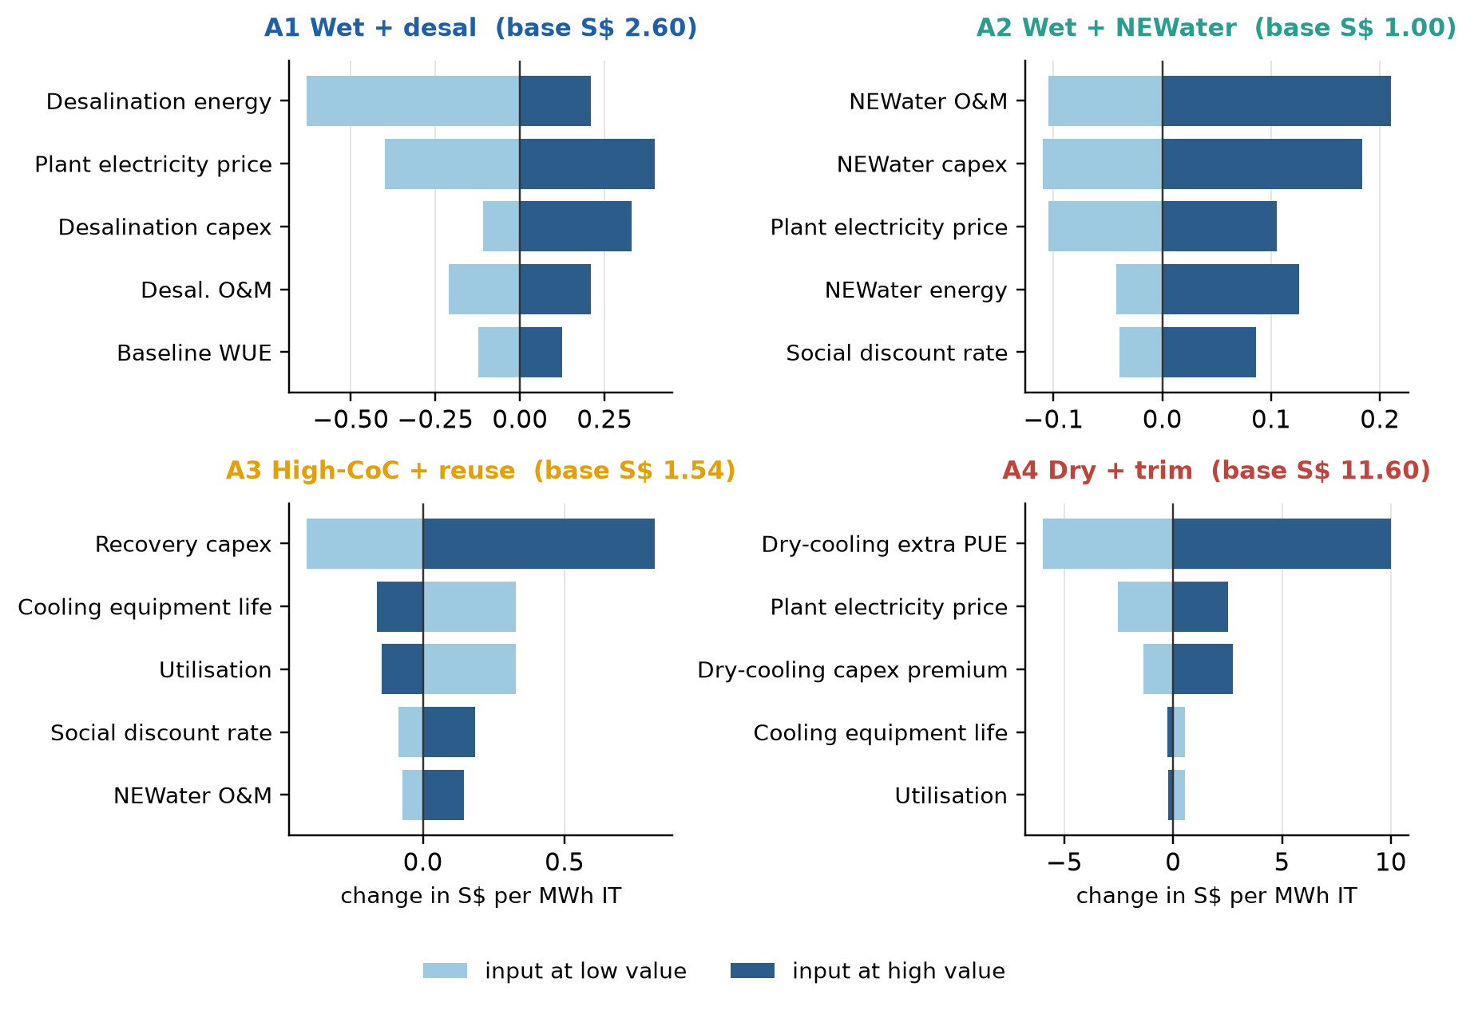
All inputs together (Monte Carlo). We drew 10,000 sets of the 32 uncertain inputs from triangular distributions (seed 29) and re-ran the model each time. Table 10 shows how often each option comes out best.
Table 10. Share of the 10,000 draws in which each option is best on the criterion. The first three rows use the model inputs only. The fourth also uses the base AHP judgements.
Question | A1 | A2 | A3 | A4
Lowest resource cost | 0.0% | 100.0% | 0.0% | 0.0%
Lowest operator cost | 0.0% | 39.5% | 60.5% | 0.0%
Lowest carbon emissions | 0.0% | 0.0% | 100.0% | 0.0%
First in the AHP (balanced weights) | 0.0% | 0.0% | 100.0% | 0.0%

Two rankings did not change in any of the 10,000 sampled combinations: A2 has the lowest resource cost and A3 the lowest carbon. Joint boundary cases inside the declared ranges can still reverse them. With recovery capital at S$30,000/MW, a 20-year equipment life and 85% utilisation, A3's resource cost (S$0.992) falls just below A2's (S$0.997); with 4 and 6 cycles, 2 kWh/m³ recovery energy and NEWater and conveyance energy at their low bounds, A3's emissions (0.826 kg) rise just above A2's (0.823 kg). These are boundary stress cases. The operator result is less clear: A3 has the lower operator cost in 60.5% of the sampled parameter combinations and A2 in 39.5%. These shares describe the ranges we sampled.
Break-even checks. Table 11 asks how wrong an input would need to be to change a conclusion.
Table 11. Break-even values. A negative break-even PUE means that, at the assumed capital premium, resource-cost parity would require an electricity advantage over wet cooling, which lies outside the positive-penalty range used in the main analysis; at zero penalty A4 still costs S$1.60/MWh against A2's S$1.00.
Question | Base value | Break-even value
A4 matches A2 on resource cost: extra dry-cooling PUE of | 0.05 | -0.0030
A4 matches A2 for the operator: extra dry-cooling PUE of | 0.05 | 0.0084
A4 matches A2 on carbon: extra dry-cooling PUE of | 0.05 | 0.0019
Desalination matches NEWater on carbon: desalination energy, kWh/m³ | 3.50 | 0.52
Operator is no better off with A3 than A2: NEWater tariff, S$/m³ | 2.50 | 1.84
A3 costs society the same as A2: recovery capex, S$/MW IT | 60,000 | 20,196
A4 matches A2 for the operator: dry-cooling capex, S$/MW IT | 100,000 | no value works
A3 costs society the same as A2: resource cost of discharged blowdown, S$/m³ | 0.00 | 0.85

Changing the model itself (structural cases). Table 12 tests changes that are not just input ranges.
Table 12. Structural cases. Full results are in Section S9.
Case | What changes | Result
Base case | None | A2 is cheapest for society (S$1.00); A3 has the lowest carbon (0.74 kg)
Towers at 8 cycles without recovery | A3 keeps its treatment capex but recovers no blowdown | Water 1.60 m³ (A3 1.46); carbon 0.75 kg; resource cost S$1.58; operator cost S$5.14
Towers at 8 cycles without recovery, cheaper treatment | Treatment capex S$40,000 or S$20,000 per MW instead of S$60,000 | Resource cost S$1.31 or S$1.03; operator cost S$4.76 or S$4.38 (A3: S$1.54 and S$4.83)
Residual desalination | A3 and A4 use desalinated water instead of NEWater | A3 carbon rises from 0.74 to 2.44 kg; resource cost from S$1.54 to S$2.66
Priced discharge | S$1.09 per m³ of blowdown discharged | A3 (S$1.61) becomes cheaper than A2 (S$1.76) for society
Low-carbon electricity for the data centre | 50% or 80% of fan electricity at 0.05–0.30 kg CO₂e/kWh | A4 carbon falls from 19.71 to 6.1–17.5 kg, still above every other option

The S$20,000 and S$40,000/MW treatment allowances are illustrative scenarios. Both omit incremental non-energy operating costs.
Towers at 8 cycles without recovery give most of A3's water saving; with cheaper treatment equipment they beat A3 on both cost measures, so recovery itself needs its own justification (operator cost S$4.76 or S$4.38/MWh against S$4.83 for A3). The residual-desalination case shows A3's carbon advantage depends on NEWater. The discharge case shows a modest price on discharge flips the cost comparison between A2 and A3; the crossover is about S$0.85/m³ (Table 11), and the S$1.09 case is an illustrative scenario at the waterborne fee. The low-carbon case shows that even with clean electricity for the fans, A4 stays well above the other options.
Changing the AHP weights and judgements. We varied the weights and the pairwise judgements together in 2,000 trials (seed 2901). Table 13 shows how often each option ranks first.
Table 13. Share of simulations in which each option is first. These are stress tests under the stated sampling design.
Option | Parameters only | Preferences only | Combined full | Combined reduced
A1 | 0.0% | 0.4% | 0.5% | 0.7%
A2 | 0.0% | 2.1% | 3.6% | 10.1%
A3 | 100.0% | 77.7% | 76.1% | 65.2%
A4 | 0.0% | 19.9% | 19.8% | 23.9%

A3 stays first in about three-quarters of trials, and A4 takes most of the rest. When we also remove sub-criteria that overlap, A3 is first in about two-thirds. So the ranking is fairly stable, but it depends on how much weight water security gets.
Changing the scoring rule. Our linear rule compresses differences when one option is an extreme outlier. On the carbon criterion the local priorities are A1 0.295, A2 0.335, A3 0.339, A4 0.031, so A1, with three and a half times the emissions of A2, scores almost the same as A2. The ratio rule that Saaty (1980) uses for measured quantities, where priority is proportional to 1/x, gives A1 0.108, A2 0.374, A3 0.499, A4 0.019. Table 14 compares the first-ranked option under both rules. The balanced, climate and growth viewpoints still put A3 first and the PUB viewpoint still puts A4 first. The operator viewpoint becomes a near tie, with A2 numerically first by 0.0004 (A2 0.309, A3 0.309). The headline "first in four of five" therefore holds for the linear rule and becomes "first in three and a near tie in a fourth" for the ratio rule.
Table 14. First-ranked option under each viewpoint for the two scoring rules. Scores in brackets; full scores are in outputs/tables/validation_ahp_scoring.csv.
Viewpoint | Linear rule (report base): first | Ratio rule: first
W1 Balanced | A3 (0.299) | A3 (0.310)
W2 PUB / water security | A4 (0.318) | A4 (0.312)
W3 Operator / economic | A3 (0.308) | near tie: A2 first (0.3092 vs 0.3087 for A3)
W4 Climate (EMA, NGOs) | A3 (0.312) | A3 (0.357)
W5 Growth (IMDA, EDB) | A3 (0.299) | A3 (0.303)

Warmer weather than the record. The hourly record is gridded weather data for the area around the site rather than a measurement at the site. We compared it with the SingStat monthly series from the Changi climate station for the same years (Department of Statistics Singapore, 2026a; Section S5). The gridded record runs 1.37°C cooler on the monthly midrange temperature, and its mean daily maximum is 29.4°C against 31.8°C at Changi. This is a cross-location discrepancy between the east coast and a Jurong Island grid cell, not a measured bias at the site. We use it as a hypothetical warming case. Warming every hour by 1.37°C raises the hours needing trim from 4.5% to 18.8% and A4's WUE from 0.50 to 0.74 m³/MWh, so the saving against A2 falls from 76% to 65% (Table S6). That is one selected case; the register's 27°C to 32°C threshold range is a separate sensitivity in which the saving runs from 39% to 80%. A4 stays the lowest water user in every case. Its cost and carbon change little because the extra PUE is held fixed in these runs, and that is what sets them.
What holds and what does not.
Table 15. Summary of the sensitivity results.
Conclusion | Under the tested ranges and cases | Why
A4 has the highest cost and carbon | Held in every test within the 0.02 to 0.10 extra-PUE range | True in every draw, structural case and weather case; below an extra PUE of 0.0019 the carbon ranking would reverse
A4 uses the least water | Held in every test; size uncertain | True in every weather case; the saving against A2 ranges from 39% to 80%
A2 is cheapest for society | Held in all 10,000 sampled combinations | Reversed if discharge is priced at the waterborne fee, or in the joint boundary case above
A3 has the lowest carbon | Held in all 10,000 sampled combinations | Reversed if A3 must use desalinated water, or in the joint boundary case above
A3 saves the operator money | Held in 60.5% of sampled combinations, before omitted operating costs | About S$2,587 per MW IT-year at mature utilisation, or S$1,200 per commissioned MW-year over the ramped horizon, removes the saving
A3 ranks first in the AHP | Depends on weights and scoring rule | First in four of five viewpoints under the linear rule; a near tie with A2 in the operator viewpoint under the ratio rule; second in the weight sweep once water security weighs more than about 0.46

9. Discussion and recommendations
Before any ranking applies. Each option must first pass a feasibility check that this model does not perform: the local water quality must allow the assumed cycles of concentration, the dry cooler must meet the design heat load in the warmest hours, a NEWater connection must be available at the site, and the supply must meet the operator's reliability requirement. The results below assume all four are met.
For PUB. The model separates water saved from money saved. Recovery can reduce the supply that the national system has to provide, even though it raises the resource cost. Higher cycles plus recovery reduce make-up withdrawals by 0.64 m³/MWh relative to ordinary towers: 0.50 comes from increasing cycles and 0.14 from recovery. Modelled evaporation remains 1.40 m³/MWh, so the reduction is in blowdown rather than evaporative loss. A claim for support would need evidence of what that saved supply is worth, such as avoided infrastructure, which we have not estimated. The model gives a performance level to test against: towers at 8 cycles reach 1.60 m³/MWh and 1.46 with recovery under our assumptions, against the Roadmap target of 2.0 and the sector median of 2.10. Before any figure near 1.5 m³/MWh is used as a condition, PUB would need site evidence that those cycles and recovery rates can be held with the local water quality.
For IMDA and EDB. Two liquid-cooled sites can have very different water demand depending on whether they use towers or dry cooling. We recommend that bidders report annual PUE and WUE together, so the trade-off is visible. The break-even PUE of 0.0019 in Table 11 shows how small the extra energy of a dry system must be before it beats NEWater-fed towers on carbon. It can help set what performance evidence to ask for; it is not a design standard.
For data-centre operators. The base case supports looking first at higher cycles of concentration, which give most of the water saving, and then at recovery. The modelled operator saving is small, about S$0.42/MWh, and disappears if the recovery unit's maintenance, chemicals and membranes cost more than about S$2,587 per MW-year, or S$1,200 per commissioned MW-year over the ramped horizon. Towers at 8 cycles with cheaper treatment equipment can beat A3 on the operator's bill (Table 12), so recovery should be checked against supplier quotes and measured recovery rates before any investment. Dry cooling saves the most water. It reaches operator-cost parity with A2 only below an extra PUE of about 0.0084 and carbon parity below 0.0019; resource-cost parity requires either a lower capital premium together with a sufficiently small energy penalty, or a net electricity advantage. It makes sense only with measured performance near those levels, if water savings are valued much more highly, or if the site has another reason to avoid wet cooling.
NEWater against desalination. NEWater is cheaper and lower in carbon under our assumptions. Desalination still gives a supply that does not depend on used-water feedstock. A result on cost and carbon alone does not make it the worse choice on every sustainability criterion.

10. Limitations
- The water benchmark is borrowed and the dry-cooling inputs are assumed. The 2.10 m³/MWh figure that anchors A1 and A2 is PUB's median for data centres already operating in Singapore, and we apply it to new liquid-cooled sites that may behave differently. Our own heat balance gave 2.30 m³/MWh at 3 cycles, and we scaled the curve down by 10% to match the benchmark, which means the benchmark cannot also be used to check the curve. If the new sites turn out to use less water than today's fleet, every absolute water figure in the report is too high, although the ratios between the options, which follow from the tower water balance, would change much less. The dry-cooling electricity penalty, its capital premium and the 80/20 heat split are likewise our own assumptions rather than measurements or quotations, and Section 8 shows that the penalty alone decides whether A4 is the worst option on cost and carbon or close to the best.
- Some flows are left outside the system boundary. We do not count the collection and basic treatment of used water before it becomes NEWater, the emissions from manufacturing the cooling equipment, or the water used to generate electricity. The first affects the options that use NEWater, A2 and A3 most of all, so their carbon figures are, if anything, slightly low relative to A1. The second affects A3 and A4, which need extra equipment, so A3's carbon advantage over A2 is slightly overstated and A4's carbon penalty slightly understated. The third would add a small water use to A4's fan electricity and so narrow its water saving a little. We also report brine and blowdown as volumes without assessing what they do to the sea, and we quantify only climate change and water use, so an option could rank differently if marine discharge or other impacts were assessed properly.
- We make several assumptions, such as commissioning dates and phasing, as a part of the modeling process. In addition, prices are held constant in real terms, with no forecast of tariffs, equipment replacement or future water-price changes. If commissioning slips, the discounted totals in Table 7 fall but the per-MWh comparison in Table 6, which drives the ranking, is unchanged. If NEWater tariffs or electricity prices rise faster than inflation, the operator's case for recovery (A3) strengthens and the case for dry cooling (A4) weakens further.
- The weather record is gridded data, and it may be too cool. The hourly weather we use is a gridded dataset (Open-Meteo) for Jurong Island rather than a measurement at the site, and it runs about 1.37°C cooler than the Changi station series on the east of the island. If the sites are really as warm as Changi, A4 needs its wet trim on about 19% of hours instead of 4.5%, and its water use rises from 0.50 to 0.74 m³/MWh; it would still use the least water. The record also shows the share of hours above 30°C rising from 0% in 2015 to 16% in 2025 while the annual mean barely moves, which could be real warming or a change in the underlying data product; we could not tell which, and we have not adjusted for future warming either. Both effects push A4's water use up, so our A4 water figure is more likely too low than too high (Section S3).
- Inputs are treated as independent. In reality, hot weather, energy penalties, utilisation and water use move together. A correlated draw could change the uncertainty ranges in either direction; we have not implemented one.
- We do not account for some components of operating cost. The recovery unit's maintenance, chemicals and membrane replacement are not costed. These costs fall only on A3, so leaving them out favours A3. The modelled operator saving of A3 over A2 is small, S$0.42/MWh, and it disappears if the uncosted items exceed about S$2,600 per MW of IT per year, roughly 4% of the assumed equipment cost each year. The resource-cost gap between A3 and A2 would widen by a similar amount.
- The AHP judgements and scoring rule are ours. The pairwise judgements for the five qualitative criteria and the five weighting cases are our own, and we did not interview PUB, IMDA or any operator. The ranking therefore shows how the options compare under priorities that we stated, and the result that A3 comes first is the one most dependent on those choices. Table 14 shows that even the rule for turning measured numbers into scores can move one viewpoint from A3 first to a tie with A2.
- Simulation shares are conditional. The percentages in Tables 10, 13 and S9 say how often an option comes out best within the ranges we chose to sample. A different set of ranges would give different percentages, so they are a stress test of our conclusions rather than the probability that a technology will perform best at a real site.

11. Conclusion
We set out to answer one question: how Singapore can meet the cooling-water needs of its new data centres at reasonable cost, with low carbon, and without straining the water system. For the 200 MW allocated under DC-CFA2, ordinary wet cooling needs about 2.58 million m³ of water a year once the sites are fully loaded, which is about 0.4% of the water Singapore sold in 2025. Running the towers at higher cycles of concentration and recovering the blowdown (A3) brings this down to 1.79 million m³, and dry cooling with a small wet share (A4) to 0.61 million m³, or about 0.90 million m³ if the sites are as warm as the Changi record suggests.
No option wins on everything. Feeding ordinary towers with NEWater (A2) is the cheapest for society at S$1.00 per MWh and is the natural baseline. A3 saves 30% of the water and 25% of the carbon relative to A2, and under our assumptions it also saves the operator money, but it costs society about S$0.54 more per MWh because the recovery equipment costs more than the water it saves. A4 saves 76% of the water, but with our assumed energy penalty it uses so much extra electricity that it emits about twenty times more carbon than A2 and costs society about twelve times more. Weighing these together in the AHP, A3 comes first under four of our five weighting cases (under the alternative ratio scoring rule the operator case becomes a near tie with A2), and A4 comes first only when water security is given more than about 0.46 of the total weight. We therefore see higher-cycle towers with recovery (A3), or at least towers run at higher cycles, as the sensible next step for new sites, and dry cooling as a choice that needs measured evidence first.
What we learned from the sensitivity work is that the choice turns on a small number of inputs that nobody has yet measured for these sites. The most important is the extra electricity that dry cooling needs: our base value of 0.05 PUE makes A4 the worst option on cost and carbon, but a value below about 0.002 would bring it level with NEWater-fed towers on carbon while keeping its water saving. The others are the NEWater tariff (recovery stops paying for the operator below S$1.84/m³), the cost of the recovery equipment (A3 matches A2 for society below about S$20,000 per MW), whether discharged blowdown is given a cost (about S$0.85/m³ flips the A2 and A3 comparison), and the share of heat a dry system can really take in Singapore's climate. These thresholds are, in our view, the most useful output of the study. They tell PUB and IMDA what evidence to ask bidders for, and they tell operators which supplier figures to check before committing. Site measurements and supplier quotations are what would settle them.

References
Department of Statistics Singapore. (2026a). Air temperature and sunshine, relative humidity and rainfall, monthly [Data set; Changi climate station from January 1984]. data.gov.sg. https://data.gov.sg/datasets/d_1744ca68dc7ed37221b17c441042405e/view
Department of Statistics Singapore. (2026b). Water sales, annual [Data set]. data.gov.sg. https://data.gov.sg/datasets/d_9db4902c7a47357441dac7d2806032a5/view
Economic Development Board, & Infocomm Media Development Authority. (2026, August 21). Four data centre proposals selected as part of second Data Centre Call for Application [Fact sheet]. https://www.edb.gov.sg/en/about-edb/media-releases-publications/four-data-centre-proposals-selected-as-part-of-second-data-centre.html
Energy Market Authority. (2026). Singapore energy statistics 2026: Chapter 2, energy transformation [Table 2.3, electricity grid emission factor]. https://www.ema.gov.sg/resources/singapore-energy-statistics/chapter2
Infocomm Media Development Authority. (2024). Green data centre roadmap. https://www.imda.gov.sg/-/media/imda/files/how-we-can-help/green-dc-roadmap/green-dc-roadmap.pdf
International Organization for Standardization. (2006a). Environmental management: Life cycle assessment. Principles and framework (ISO Standard No. 14040:2006).
International Organization for Standardization. (2006b). Environmental management: Life cycle assessment. Requirements and guidelines (ISO Standard No. 14044:2006).
Ministry of Digital Development and Information. (2026, October 7). Closing speech by SMS Tan Kiat How for the second reading of the Digital Infrastructure Bill. https://www.mddi.gov.sg/newsroom/closing-speech-by-sms-tan-kiat-how-for-the-second-reading-of-the-digital-infrastructure-bill/
Ministry of Energy, Trade and Industry. (2026, September 10). Written reply to PQ on electricity demand from grid versus on-site generation and proportion of green energy commitment from local renewable generation versus imported sources for DC-CFA2. https://www.meti.gov.sg/newsroom/written-reply-to-pq-on-electricity-demand-from-grid-versus-on-site-generation-and-proportion-of-green-energy-commitment-from-local-renewable-generation-versus-imported-sources-for-dc-cfa2/
Mytton, D. (2021). Data centre water consumption. npj Clean Water, 4, Article 11. https://doi.org/10.1038/s41545-021-00101-w
National Climate Change Secretariat. (2026, July 9). Carbon tax. https://www.nccs.gov.sg/singapores-climate-action/mitigation-efforts/carbontax/
Open-Meteo. (n.d.). Historical weather API [Documentation]. Retrieved October 25, 2026, from https://open-meteo.com/en/docs/historical-weather-api
Public Utilities Board. (2014, September 18). BESIN-UEN Consortium to build second NEWater plant at Changi [Press release]. National Archives of Singapore. https://www.nas.gov.sg/archivesonline/data/pdfdoc/20140925002/pr20140918_2nd_changi_newater_plant_award_press_release_sally.pdf
Public Utilities Board. (2023a, March). PUB's decarbonisation strategy [Press release]. https://www.pub.gov.sg/Resources/News-Room/PressReleases/2023/03/PUB-decarbonisation-strategy
Public Utilities Board. (2023b, September 27). Water price to rise from April 2024; Government to provide support for lower- and middle-income households [Press release, Annexes A and B]. https://www.pub.gov.sg/Resources/News-Room/PressReleases/2023/09/Water-price-to-rise-from-April-2024-Government-to-provide-support
Public Utilities Board. (2025, December). Sectoral water efficiency benchmark. https://www.pub.gov.sg/Public/WaterLoop/Water-Conservation/Resources-on-Water-Efficiency-Measures/Sectoral-Water-Efficiency-Benchmark
Saaty, T. L. (1980). The analytic hierarchy process: Planning, priority setting, resource allocation. McGraw-Hill.
Shehabi, A., Smith, S. J., Hubbard, A., Newkirk, A., Lei, N., Siddik, M. A. B., Holecek, B., Koomey, J., Masanet, E., & Sartor, D. (2024). 2024 United States data center energy usage report (LBNL-2001637). Lawrence Berkeley National Laboratory. https://doi.org/10.71468/P1WC7Q
Sustainability Impact Metrics. (2026). Eco-costs 2026 midpoint tables [Data set]. https://www.ecocostsvalue.com/EVR/img/Ecocosts2026_midpoint_tables.xlsx

Supplementary material
The sections below hold the detail behind the main report. They are meant for readers who want to check the numbers.

S1. Full register of model inputs
Table S1. All active numerical assumptions. Context and calibration-only entries stay in config/assumptions.csv but are not varied in the uncertainty tests unless they affect a reported result.
Parameter and unit | Low / base / high | Status | Source or basis
DC-CFA2 provisionally allocated IT capacity (MW_IT) | 200 / 200 / 200 | verified | EDB/IMDA August 2026; MDDI 7 October 2026 Digital Infrastructure Bill closing speech
Hypothetical second non-overlapping IT-capacity tranche (MW_IT) | 0 / 300 / 300 | team-judgement | Team growth scenario; not a published Roadmap increment
Hypothetical third non-overlapping IT-capacity tranche (MW_IT) | 0 / 200 / 500 | team-judgement | Team growth scenario; not an awarded or forecast tranche
Share of allocated MW that is IT load (1/PUE if MW = facility power) (fraction) | 1.000 / 1.000 / 1.000 | verified | MDDI 7 October 2026 closing speech on Digital Infrastructure Bill
Average IT utilisation (energy-weighted load factor) (fraction) | 0.500 / 0.700 / 0.850 | to-verify | Shehabi et al. (2024) context; Uptime Institute surveys not retained; team-selected range
Years from assumed commissioning to mature average utilisation (years) | 2 / 3 / 5 | team-judgement | Team assumption
WUE baseline - evaporative cooling towers (SG median) (m3/MWh_IT) | 2.000 / 2.100 / 2.200 | benchmark-derived | PUB Sectoral Water Efficiency Benchmark (Dec 2025) = 2.1; IMDA 2021 median = 2.2
Cycles of concentration - typical (-) | 2.500 / 3.000 / 4.000 | to-verify | IMDA (2024) Green DC Roadmap discussion of CoC; range is a team assumption
Cycles of concentration - best practice with advanced treatment (-) | 6.000 / 8.000 / 12.000 | to-verify | Team screening assumption; no verified source established
Incremental PUE of dry versus wet heat rejection on common liquid-cooled IT (-) | 0.020 / 0.050 / 0.100 | team-judgement | Illustrative team range; equipment performance not measured at a Singapore site
Specific energy - seawater RO desalination incl. intake/pre-treatment (kWh/m3) | 2.000 / 3.500 / 4.000 | verified | PUB (2023a): historical reference near 3.5 kWh/m3; target below 2 kWh/m3
Specific energy - NEWater (MF/UF + RO + UV) (kWh/m3) | 0.600 / 0.700 / 1.000 | to-verify | Team screening assumption; no verified source established; team-recalled 0.6-0.8 kWh/m3 range for the Changi NEWater plant study, document not retained
Conveyance/distribution pumping to Jurong Island (kWh/m3) | 0.200 / 0.300 / 0.500 | to-verify | Team screening assumption; no verified source established
Energy for side-stream treatment / blowdown RO per m3 recovered (kWh/m3) | 0.500 / 1.000 / 2.000 | to-verify | Team screening assumption; no verified source established
Embodied infrastructure + chemicals - desalination (kgCO2e/m3) | 0.050 / 0.150 / 0.400 | team-judgement | Illustrative screening factor; no plant-specific inventory verified
Embodied infrastructure + chemicals - NEWater (kgCO2e/m3) | 0.030 / 0.080 / 0.200 | team-judgement | Illustrative screening factor; no plant-specific inventory verified
Grid emission factor 2035 - business as usual (kgCO2/kWh) | 0.360 / 0.380 / 0.400 | team-judgement | Extrapolation of EMA T2.3 series 2005-2025 (0.526 -> 0.404)
Grid emission factor 2035 - low-carbon grid case (imports + solar + H2) (kgCO2/kWh) | 0.150 / 0.250 / 0.300 | to-verify | EMA target of up to 6 GW low-carbon imports by 2035
Desalination capital cost per unit daily capacity (SGD per m3/d) | 1,300 / 1,600 / 2,500 | team-judgement | Historical Tuas 2018 capital intensity used only to anchor an illustrative range
NEWater capital cost per unit daily capacity (SGD per m3/d) | 700 / 1,000 / 1,500 | team-judgement | Illustrative capital-intensity assumption; plant-specific evidence incomplete
Desal O&M excl. electricity (SGD/m3) | 0.100 / 0.200 / 0.300 | to-verify | Team screening assumption; no verified source established
NEWater O&M excl. electricity (SGD/m3) | 0.050 / 0.100 / 0.200 | to-verify | Team screening assumption; no verified source established
Potable water price to non-domestic user (2025) (SGD/m3) | 2.740 / 3.240 / 3.240 | verified | PUB (2023): non-domestic 2.74 -> 3.24 from Apr 2025 (tariff + WCT + waterborne fee)
NEWater all-in non-domestic price from April 2025 (SGD/m3) | 2.500 / 2.500 / 2.500 | verified | PUB 2023 water-price announcement Annex B live verification 25 October 2026
Electricity price paid by the DC operator (SGD/kWh) | 0.200 / 0.250 / 0.300 | proxy | Illustrative retail electricity-price proxy informed by historical tariff context
Capex: side-stream treatment + blowdown recovery (SGD per MW_IT) | 30,000 / 60,000 / 120,000 | team-judgement | Illustrative team capital range; vendor quote not available
Assumed economic life of water plants (years) | 20 / 25 / 30 | team-judgement | Team assumption informed by historical 25-year water-supply concessions
Life of DC cooling equipment (years) | 10 / 15 / 20 | team-judgement | Team screening assumption; no verified source established
Discount rate - public/social perspective (%/yr) | 2.000 / 3.000 / 5.000 | team-judgement | Lecture eLCC example uses 3%
Discount rate - operator WACC (%/yr) | 6.000 / 8.000 / 10.000 | team-judgement | Lecture LCOE case uses 10% WACC
Singapore carbon tax 2026-2027 (SGD/tCO2e) | 45.000 / 45.000 / 45.000 | verified | NCCS
Singapore carbon tax 2030 onwards (SGD/tCO2e) | 50.000 / 65.000 / 80.000 | scenario | NCCS published 2030 range of S$50-80/t; team-selected midpoint of S$65/t
Eco-cost of GWP100 (externality monetisation) (EUR/kgCO2e) | 0.123 / 0.150 / 0.200 | benchmark-derived | Sustainability Impact Metrics retained eco-cost workbook; 'ecocosts emissions 2025' row 139 CO2 factor = 0.15 EUR/kg
Study horizon start (year) | 2027 / 2027 / 2027 | scenario | Study horizon selected in the submitted proposal
Study horizon end (year) | 2035 / 2035 / 2035 | scenario | Study horizon selected in the submitted proposal
Electricity cost for water plants (wholesale USEP 2023-25 avg + network charge) (SGD/kWh) | 0.150 / 0.200 / 0.250 | proxy | EMC USEP via EMA: 2023-25 mean 0.176 SGD/kWh + ~0.03 network/market charges
FX EUR to SGD (SGD/EUR) | 1.400 / 1.450 / 1.500 | team-judgement | Illustrative conversion sensitivity; not a verified October 2026 exchange-rate quote
SWRO recovery ratio (product / seawater feed) (fraction) | 0.400 / 0.450 / 0.500 | team-judgement | Team screening assumption; no verified source established; typical SWRO practice
NEWater RO recovery ratio (fraction) | 0.700 / 0.750 / 0.850 | team-judgement | Team screening assumption; no verified source established; typical water-reuse RO practice
Share of blowdown recovered and reused on site (A3) (fraction) | 0.500 / 0.700 / 0.800 | team-judgement | Illustrative treatment-recovery range; not inferred directly from electro-oxidation savings
Dry-bulb above which dry coolers need adiabatic trim (A4) (degC) | 27.000 / 30.000 / 32.000 | team-judgement | Facility water 35 C (ASHRAE W32/W40) minus ~5 K approach
Share of IT heat routed from the common liquid loop to dry rejection in A4 (fraction) | 0.700 / 0.800 / 0.900 | team-judgement | Illustrative heat-routing share; no facility heat balance verified
Water plant capacity factor (fraction) | 0.850 / 0.900 / 0.950 | team-judgement | Team screening assumption; no verified source established
Incremental capital for dry/trim rejection versus wet rejection (SGD per MW_IT) | 0 / 100,000 / 300,000 | team-judgement | Illustrative team assumption; no vendor quote

S2. Equations and a worked example
Water demand. Annual IT energy = capacity × utilisation × ramp × 8,760 h. Make-up water = IT energy × WUE.
Carbon per MWh of IT energy. CO₂e = (electricity for water + electricity for dry fans) × grid factor + water × non-energy factor.
Cost per MWh of IT energy. Cost = water × (LCOW + conveyance cost) + equipment charge + extra electricity × price.
Levelised cost of water. LCOW = (capital recovery factor × capital cost) ÷ (365 × capacity factor) + non-energy running cost + specific energy × electricity price. This is the standard levelised-cost form with constant annual costs and zero salvage value.
Table S2. Worked calculation for A3 per MWh of IT energy. The capital recovery factors use a 15-year life at 3% (society) and 8% (operator). 6,132 MWh is the yearly IT energy of 1 MW at 70% utilisation.
Step | Calculation | Result
Make-up water | WUE for A3 | 1.46 m³
Production electricity | 1.46 m³ × 0.7 kWh/m³ | 1.02 kWh
Conveyance electricity | 1.46 m³ × 0.3 kWh/m³ | 0.44 kWh
Recovery electricity | 0.14 m³ recovered × 1 kWh/m³ | 0.14 kWh
Electricity, total | sum | 1.6 kWh
CO₂e from electricity | 1.6 kWh × 0.3896 | 0.62 kg
CO₂e non-energy | 1.46 m³ × 0.08 kg/m³ | 0.12 kg
Total CO₂e | sum | 0.74 kg
Equipment charge, society | S$60,000 × 0.08377 ÷ 6,132 MWh | S$0.82
Equipment charge, operator | S$60,000 × 0.11683 ÷ 6,132 MWh | S$1.14

Table S3. Resource cost per MWh of IT energy by component, S$.
Option | Water | Equipment | Extra electricity | Total
A1 Wet + desal | 2.60 | 0.00 | 0.00 | 2.60
A2 Wet + NEWater | 1.00 | 0.00 | 0.00 | 1.00
A3 Towers + reuse | 0.69 | 0.82 | 0.03 | 1.54
A4 Dry + wet trim | 0.24 | 1.37 | 10.00 | 11.60

Table S4. Operator cost per MWh of IT energy by component, S$.
Option | Water bill | Equipment | Extra electricity | Total
A1 Wet + desal | 6.80 | 0.00 | 0.00 | 6.80
A2 Wet + NEWater | 5.25 | 0.00 | 0.00 | 5.25
A3 Towers + reuse | 3.65 | 1.14 | 0.03 | 4.83
A4 Dry + wet trim | 1.24 | 1.91 | 12.50 | 15.64

S3. Weather data and water balance
The weather file has 96,432 hourly records for 2015 to 2025. We check timestamps, missing values, duplicates and coverage. For the dry-cooling threshold we count the archived hours above it, instead of interpolating. The share of hours above 30°C is 4.5%. The Open-Meteo request did not pin a weather model, so the record is not described as ERA5-only (Open-Meteo, n.d.), and it represents conditions near the site rather than an on-site sensor. By year, the share above 30°C runs from 0.0% in 2015 to 15.9% in 2025 while the annual mean temperature changes by less than 0.6°C (Table S6b in Section S5). At the 2025 share alone, A4's WUE would be 0.69 m³/MWh and its saving against A2 67%. The pooled share is used in the base case; a re-fetch with a single pinned model is the next check.
The water balance is checked separately from the cost model. At the base settings the evaporation term is 1.40 m³/MWh. Raising cycles of concentration from 3 to 8 reduces blowdown before recovery to 0.20 m³/MWh. Recovering 70% returns 0.14 m³/MWh and leaves 0.06 m³/MWh to discharge. Treatment electricity is charged only to the recovered water.

S4. Levelised cost of water
The calculated LCOW is S$1.18/m³ for desalination and S$0.41/m³ for NEWater. Figure S1 compares these with historical concession prices, which are shown for context only.
Figure S1. Modelled water cost and historical concession prices.
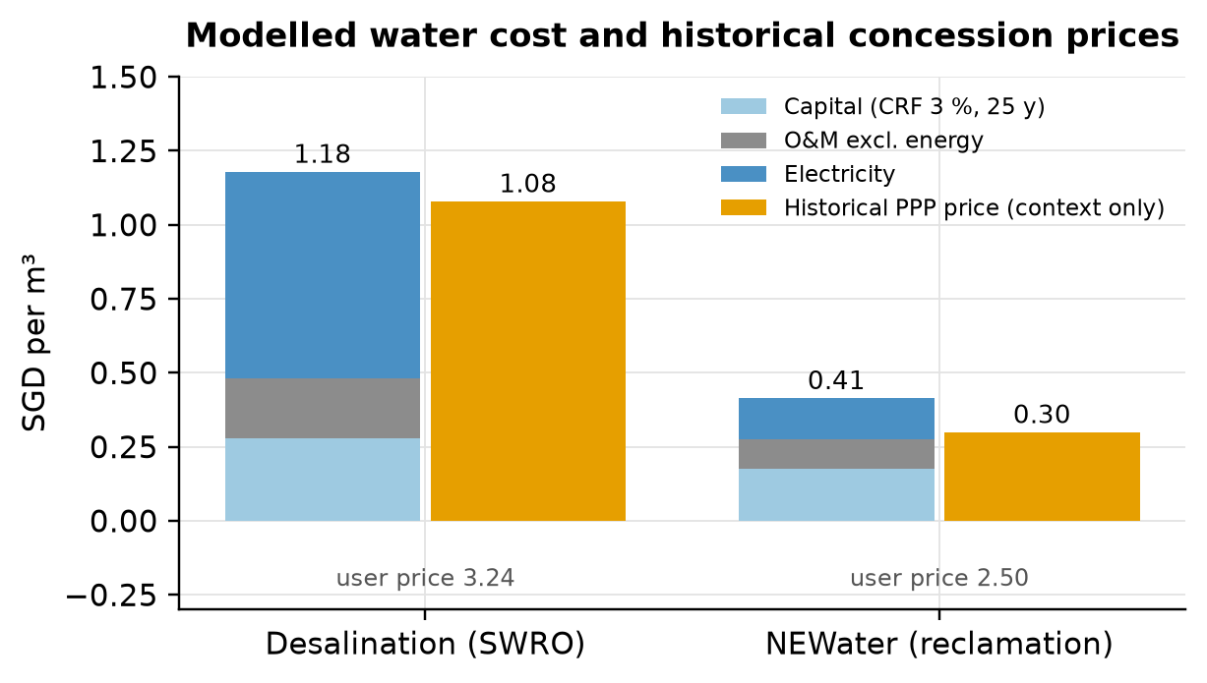

S5. Weather record against a station series
The SingStat monthly climate series on data.gov.sg (Department of Statistics Singapore, 2026a) gives mean daily maximum and minimum temperatures by month. Its footnote states that from January 1984 the data come from the designated climate station at Changi. We averaged the Open-Meteo hourly record to the same monthly midrange, (maximum + minimum) ÷ 2, and compared the two for 2015 to 2025 (Table S5). The gridded record is cooler throughout. Because the station is on the east coast and the data-centre sites are in the west, this is a cross-location comparison, and we do not correct the record; we show the effect of a warmer record on A4 in Table S6. Warming every hour by b degrees is equivalent to lowering the trim threshold by b, which is how the cases were run.
Table S5. Open-Meteo gridded record for Jurong Island against the SingStat series from the Changi climate station.
Check (2015–2025) | Value
Months compared | 132
Open-Meteo minus station, monthly midrange temperature | −1.37 °C (gridded record cooler)
Root-mean-square monthly difference | 1.42 °C
Largest monthly difference | 2.25 °C
Month-to-month correlation | 0.84
Mean daily maximum, Open-Meteo vs station | 29.4 vs 31.8 °C

Table S6. A4 under warmer conditions and at the register's threshold bounds. Cost and carbon change little because fan electricity dominates them.
Case | Hours needing trim | A4 WUE, m³/MWh | Saving vs A2 | 2035 water, S1, million m³ | A4 CO₂e, kg/MWh
Base (30 °C threshold, record as archived) | 4.5% | 0.50 | 76% | 0.61 | 19.71
Record warmed by 0.5 °C | 7.9% | 0.55 | 74% | 0.68 | 19.74
Record warmed by 1.0 °C | 13.2% | 0.64 | 69% | 0.79 | 19.78
Hypothetical warming by the cross-location difference (1.37 °C) | 18.8% | 0.74 | 65% | 0.90 | 19.83
Register low bound: 27 °C threshold | 50.9% | 1.27 | 39% | 1.56 | 20.08
Register high bound: 32 °C threshold | 0.4% | 0.43 | 80% | 0.52 | 19.68

Table S6b. Share of archived hours above 30°C in each year, the annual mean temperature, and the A4 WUE that each year's share would imply on its own.
Year | Hours above threshold | Annual mean, °C | A4 WUE at that share, m³/MWh | Saving vs A2
2015 | 0.0% | 27.1 | 0.42 | 80%
2016 | 0.9% | 27.5 | 0.44 | 79%
2017 | 1.3% | 27.1 | 0.44 | 79%
2018 | 1.2% | 27.0 | 0.44 | 79%
2019 | 4.3% | 27.3 | 0.49 | 77%
2020 | 3.1% | 27.1 | 0.47 | 78%
2021 | 2.2% | 26.9 | 0.46 | 78%
2022 | 2.5% | 26.9 | 0.46 | 78%
2023 | 7.1% | 27.0 | 0.54 | 74%
2024 | 11.0% | 27.3 | 0.60 | 71%
2025 | 15.9% | 27.4 | 0.69 | 67%

S6. Levelised cost and discount rates
The social perspective uses 3% and the operator perspective uses the 8% weighted average cost of capital in Table 3. Both are team judgements with ranges of 2 to 5% and 6 to 10%. The capital recovery factors used in Table S2 are 0.08377 and 0.11683.

S7. AHP detail
Scoring rule for model criteria. For a criterion where less is better, an option scores (worst value − its value) + 0.10 × (range between worst and best), and the scores are then normalised to sum to 1. The 0.10 floor stops the worst option from scoring zero. We also tested floors of 0.01 and 0.30, and the ratio rule in Table 14.
Worked sum for A3 under balanced weights. A3's score is the sum over the 11 sub-criteria of the global weight × A3's local priority. The global weight is the main-criterion weight × the sub-criterion's share inside it. For example, the weight of greenhouse-gas emissions is 0.25 × 0.54 = 0.135.
Table S7. Global sub-criterion weights in the balanced case.
Subcriterion | Global weight
C1a Societal life-cycle cost | 0.125
C1b Cost to DC operators | 0.125
C2a GHG per MWh_IT | 0.135
C2b Electricity use | 0.041
C2c Marine discharge (brine, blowdown) | 0.074
C3a Water drawn from national supply | 0.125
C3b Weather resilience | 0.062
C3c Dependence on used-water feedstock | 0.062
C4a Technical maturity in the tropics | 0.100
C4b Policy alignment & enforceability | 0.100
C4c Effect on other water users | 0.050

S8. Basis of the pairwise judgements
Table S8. Basis and limits of each comparison. The pairwise matrices and consistency ratios are in outputs/tables/ahp_pairwise_matrices.csv and ahp_consistency.csv.
Comparison group | Judgment basis
C1 Economic | Society and operator costs weighted equally: the price-signal gap is itself a finding.
C2 Environmental | Team scenario: GHG has the greatest weight. Electricity and discharge volume are overlapping/incomplete proxies, removed in separate sensitivity cases; discharge volume is not ecological damage.
C3 Water security | Volume drawn is PUB's planning variable; resilience and feedstock dependence are second-order.
C4 Implementation | Maturity and policy fit matter equally for a 2027 start; distributional effects slightly less.
C3b Weather resilience | Neutral team judgment: all options must meet the same cooling reliability requirement. Both supply taps are weather-resilient. Weather effects enter WUE and the energy assumptions; there are no site reliability data to justify a further advantage.
C3c Dependence on used-water feedstock | Team judgment for the NEWater-residual base case: desal needs no used-water feedstock; A2 uses most NEWater; A3/A4 use less. These ratios are illustrative, not measured scarcity or stakeholder preferences. They overlap with withdrawal and are stress-tested.
C4a Technical maturity in the tropics | Team judgment on heat rejection: conventional towers have the longest local operating record; recovery adds treatment complexity; warm-water dry/adiabatic rejection has less public Singapore operating evidence. Liquid cooling is common to all alternatives, so its adoption and the SS 726 publication date do not distinguish the options.
C4b Policy alignment & enforceability | Illustrative team ratios: NEWater and water reduction align with published efficiency objectives. A3 and A4 receive equal preference; neither receives an extra credit for liquid cooling because it is common to all. No regulator supplied these weights.
C4c Effect on other water users | Illustrative team judgment: reducing withdrawals leaves more supply available. A tariff increase caused by this tranche has not been estimated. This leaf overlaps with withdrawal/cost and is removed with other proxies in a sensitivity case.

Figure S2. Rainbow diagrams. Each panel changes one main-criterion weight from 0 to 1 and rescales the others. The dashed line marks the balanced weight.
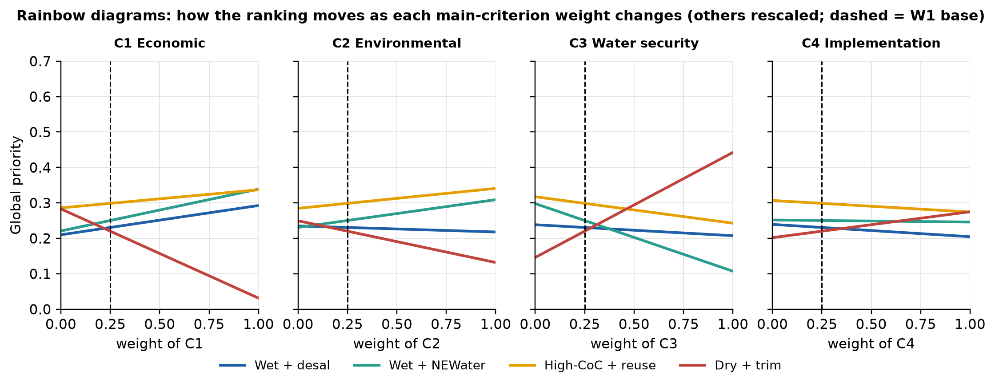
Reading Figure S2. In the C3 (water security) panel, A4 overtakes A3 at a weight of about 0.46. A2 comes first only if the economic weight is close to 1.

S9. Sensitivity detail
Design. The Monte Carlo draws each uncertain input independently from a triangular distribution and uses the same draw for all four options, so comparisons are paired. Capacity is fixed within a scenario. The preference trials draw main weights uniformly from the weight simplex (Dirichlet 1,1,1,1), perturb the pairwise ratios with log-normal noise (log standard deviation 0.35, clipped to 1/9 to 9), redraw any matrix with a consistency ratio above 0.10, and sample the scoring floor from 0.01, 0.10 and 0.30. Each accepted set is evaluated with base inputs and with sampled inputs, for the full hierarchy and for a reduced-overlap hierarchy that drops electricity use, discharge volume and the qualitative leaves that partly repeat water demand.
Table S9. Fifth to 95th percentile ranges from the Monte Carlo draws. These are conditional simulation ranges, not confidence intervals.
Option | S1 water in 2035, million m³ | Resource cost, S$/MWh
A1 | 2.05–2.95 | 2.13–3.05
A2 | 2.05–2.95 | 0.93–1.32
A3 | 1.44–2.14 | 1.37–2.48
A4 | 0.41–1.19 | 8.01–19.95

Figure S3. Distribution of the Monte Carlo results.
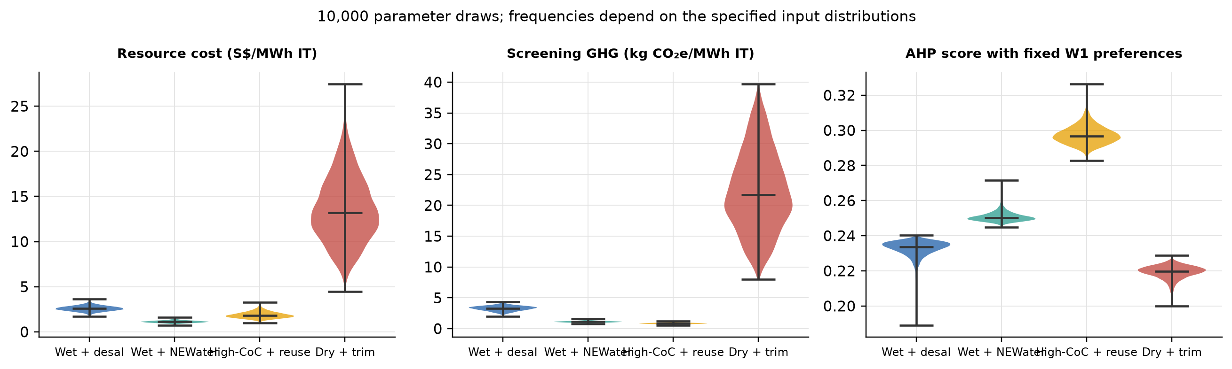
Figure S4. How often each option is best on each criterion, with fixed base preferences.
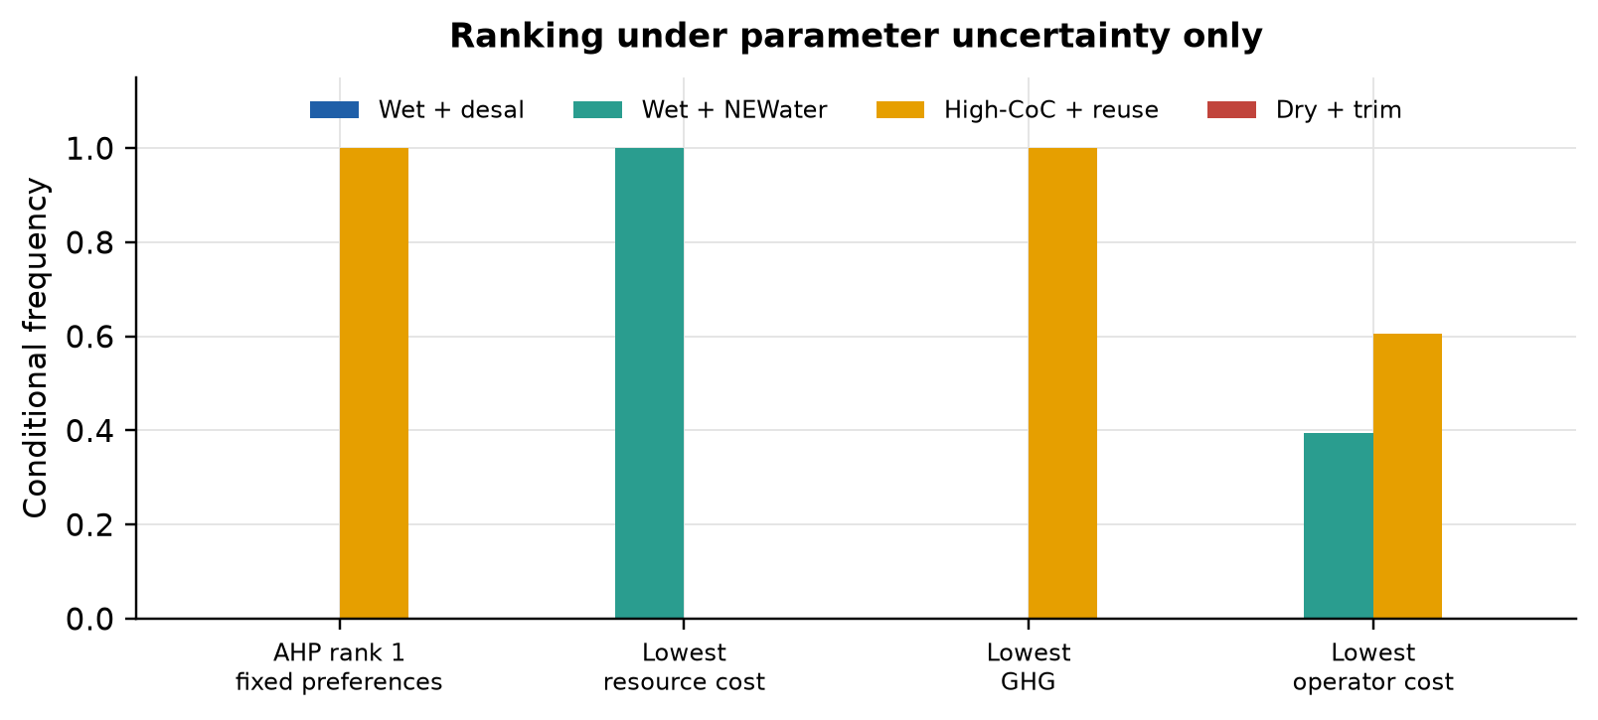
Figure S5. Carbon tornado: the inputs that move emissions most.
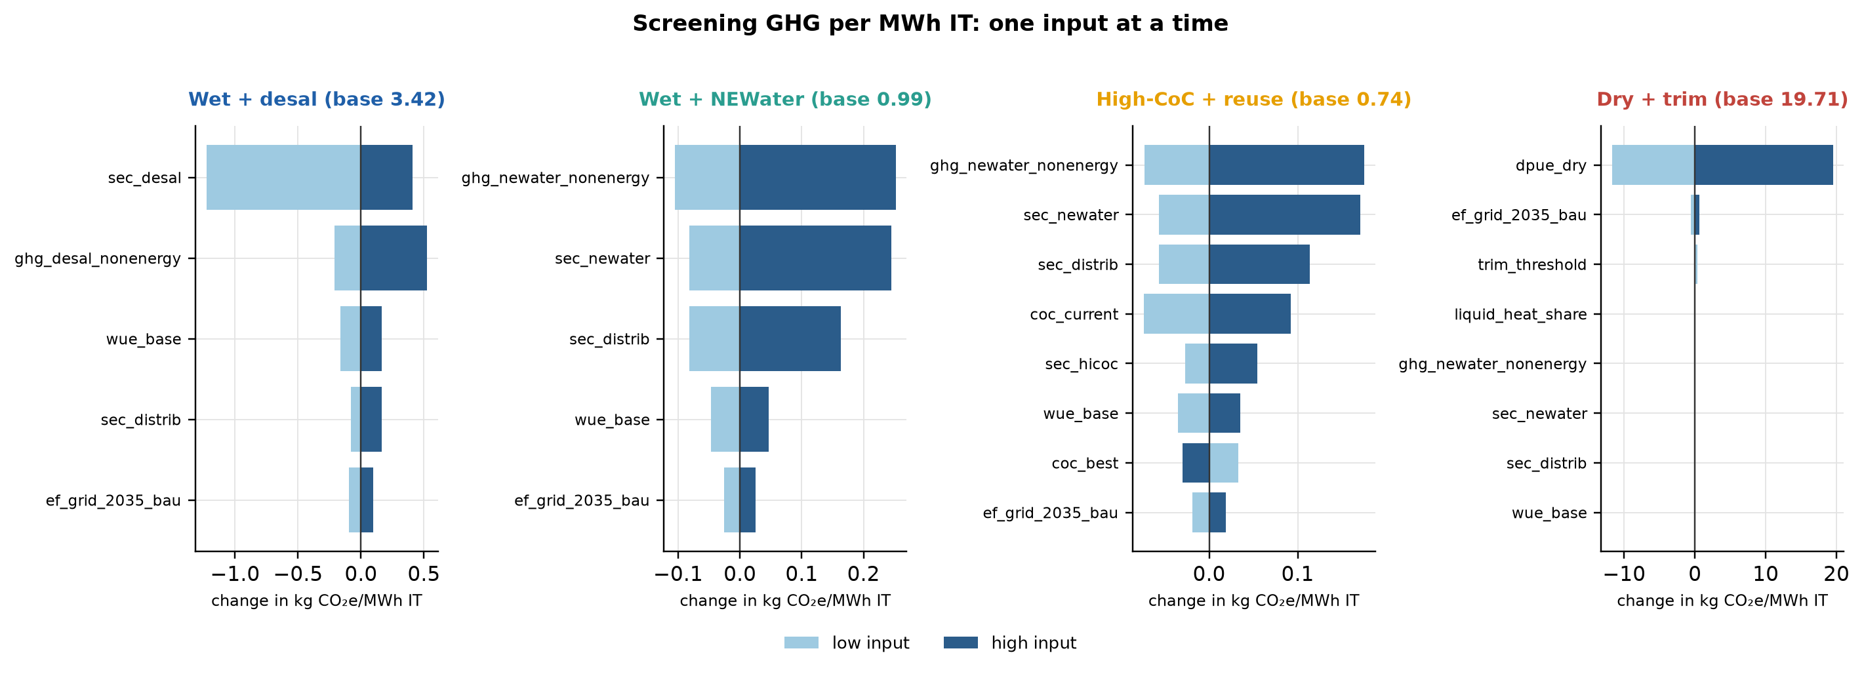

S10. Calibration, validation and checks
This is a deterministic scenario model; no statistical model is fitted, so there is no prediction error to report. We evaluate it in three ways: calibration against a benchmark, comparison with independent references, and internal consistency checks. Table S10 separates the three. The tower curve is calibrated to one benchmark, which cannot also serve as its validation, and the weather comparison in Table S5 is a descriptive cross-location check, not a validation of the site record.
Table S10. What was calibrated, what was compared with an independent reference, and what was only checked for consistency.
Component | Kind | Model value vs reference | Result
Wet-tower water use (A1, A2) | Calibration | 2.30 m3/MWh from the heat balance before scaling; PUB sector benchmark 2.10 m3/MWh | +10% before scaling; scaled to the benchmark. The benchmark sets the curve, so it cannot also validate it
Levelised cost of desalinated water | Independent context | S$1.18/m3 bottom-up; S$1.08/m3 Keppel Marina East first-year price | +9%. Different year, financing and scope; agreement in magnitude only
Levelised cost of NEWater | Independent context | S$0.41/m3 bottom-up; S$0.28 to 0.30/m3 Changi (2014) and Sembcorp (2008) first-year prices | +38% against S$0.30. Model is higher; the gap is reported, not corrected
Hourly weather for the A4 trim share | Independent record, different location | Open-Meteo gridded record, Jurong Island; SingStat monthly series, Changi climate station | -1.37 degC monthly midrange; gridded record is cooler. Cross-location discrepancy; used as a hypothetical warming case for A4
Grid emission factor | Input, not validated | 0.404 kg CO2/kWh in 2025, linear to 0.38 in 2035; EMA Singapore Energy Statistics 2026, Table 2.3 | 2025 value used directly; 2035 endpoint is a team assumption. No back-test is possible for a future path
Arithmetic and AHP mathematics | Internal check | Saved tables against fresh model calls; 17 unit tests run 2026-11-07; Independent eigenvector calculation; mass and energy balances | Maximum absolute difference 0 (saved tables versus fresh calls); all tests pass. Shows consistency, not the truth of any assumption

Checks carried out. Demand scaling, unit consistency, the timing of equipment charges and the separation of resource costs from tariffs are tested. The AHP priority vectors are compared with an independent eigenvector calculation, normalisation is verified, and the consistency criterion is enforced for every judgement matrix. Saved base tables are compared with fresh calls to the model functions. These checks show the arithmetic is consistent. They cannot show that an assumed equipment cost or a future operating condition is right.

S11. Reproducibility and AI use
The analysis reads config/assumptions.csv and the retained source data, and writes demand, LCA, LCC, AHP and sensitivity tables to outputs/tables (src/run_all.py, stages 02 to 08). src/12_validation_extras.py adds the weather comparisons, the A4 weather cases, the scoring-rule test, the calibration table and Figure 10. The report text is report_final.md in the project root; src/report_data_final.py reads the result tables and src/13_build_paper_final.py inserts the current numbers and builds the Word file. Figure 1 is drawn by src/16_draw_options_figure.py. Figures 2, 3 and 6 are diagrams supplied as image files in outputs/figures (fig_report_*.png); the script that drew them was not kept. The video deck (20 slides, deliverables/DSS5202_Group29_Video_Slides.pptx) was prepared in PowerPoint from the report figures and tables; src/17_edit_video_deck.py records the later text edits. The earlier generated deck from src/15_build_video_slides.py is kept in .build. The poster was generated on 25 October 2026 outside the Python environment; src/14_edit_presentations.py re-applies the later edits and redraws its AHP figure. The PDF was exported from the Word file with Microsoft Word (see README.md). The unit tests were last run on 2026-11-07 (17 tests, pass). Source hashes and numerical checks are in outputs/validation/.
Generative AI use. Generative AI tools (ChatGPT and Claude) assisted with model development, code checks, and drafting and editing this report. The numerical results come from the submitted Python calculations. Assumptions, source limits and the scope of the checks are stated in the report and its supporting files.

